Z:\All folders 2014\COMMUNICATION UNIT\LOGO_2014 and letter heads\undp_logo_new_eng_96dpi.jpg 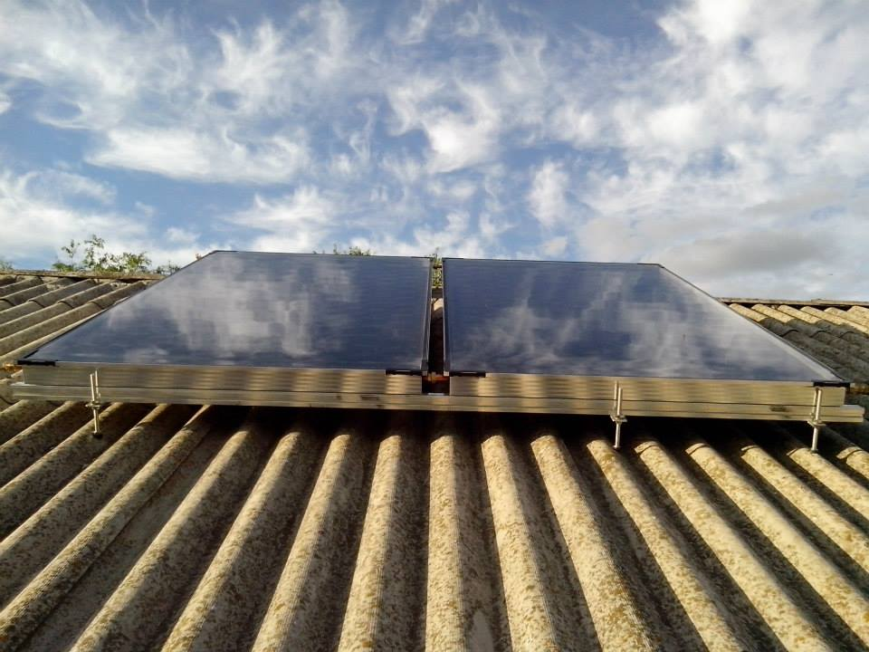

The largest cities and towns of the region are Chernihiv, Nizhyn, Pryluky and Bakhmach.

Chernihiv region mostly deals with petroleum and natural gas extraction, transport, machinery, tobacco and textile industry. Climate conditions in this area let also develop agricultural sector.

Chernihiv region has also important railway junctions as part of Ukrainian infrastructure.

Chernihiv region is located on northern part of Ukraine. It borders with Russia and Belarus on the north and such Ukrainian regions as Poltava, Sumy and Kiev. Chernihiv region territory occupies 5.3 % of the total area of Ukraine with a population of about 1.06 mln. About 64 % of the region population lives in cities and towns.

Chernihiv region includes 22 rayons, 16 cities, 29 urban villages, 1,466 villages.

KEY DATA ON THE CBA-I and CBA-II PROJECT IN CHERNIHIV REGION

The CBA Project in Chernihiv Region: Factsheet

**Chernihiv region background**

Updated 14 March 2016

Beneficiaries

62,870 men, women and children

CBA Microprojects in Chernihiv region

38 schools / kindergartens

16 health posts

10 water supply

13 street-lightning

CBA-II Coverage in Chernihiv Region

**CBA Implementation in Chernihiv Region**

Implementation of the first phase of the CBA Project commenced in Chernihiv region during June 2008. First phase was succeeded by a second phase in July 2011. Over these two phases 62870 of men, women and children of the region have benefitted from improvement in 38 schools/kindergartens, 16 health posts, 10 water supply, 13 street-lightning and so on. This happened through joint effort of the citizens, oblast/rayon/local level governments, the CBA Project and the private sponsors.

**Energy Efficiency in Chernihiv region**

***Third phase of the CBA III*** was initiated in Chernihiv region with regional launching and signing of MoU which took place on October 2nd, 2014. The region received a quota of 7 rayons for standard\replication components.

Rayons selected for the CBA-III:

*Bachmatskyi, Bobrovytskyi, Sribnianskyi, Horodnianskyi, Nizhynskyi, Semenivskyi, Sosnytskyi.*

***Micro projects approved as of 14 March 2016:*** *16 micro projects (3 – health, 8 – energy saving, 1 – water supply, 4 – energy efficiency).* Around 9,300 persons will benefit from implementation of these initiatives. Total budget for the initiatives is approx. UAH 5.5 mln (approx. USD 248,000). UNDP will provide around UAH 3.9 mln (approx. USD 176,000).

In addition, ***urban component*** of the CBA is being implemented in 2 cities – *Pryluky* and *Nizhyn*.

*Microprojects approved as of 14 March 2016*: 14 micro-projects (6 in Pryluky and 8 in Nizhyn). Around 4,300 persons will benefit from implementation of these initiatives. Total budget for the initiatives is around UAH 4.5 mln (approx. USD 202,700). UNDP will provide approx. UAH 2.2 mln (more than USD 99 ths).

[www.cba.org.ua](http://www.cba.org.ua)

20 Esplanadna Str., office 704-708, Kyiv Tel: +38 (044) 253 5975 Facebook: www.facebook.com/cbaproject

**CBA Community** **Development Officers, Chernihiv Region**

Vladyslav Syla

mob. tel: (050) 386 91 70

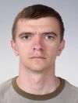

Nina Podkolzina

mob. tel: (050) 381 89 29

