Z:\All folders 2014\COMMUNICATION UNIT\LOGO_2014 and letter heads\undp_logo_new_eng_96dpi.jpg 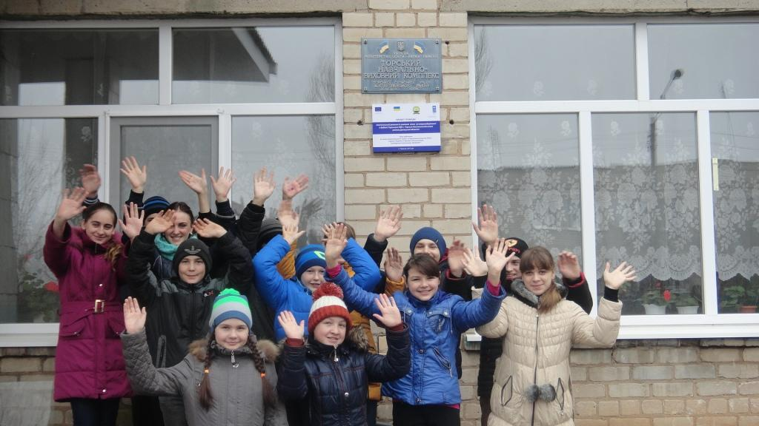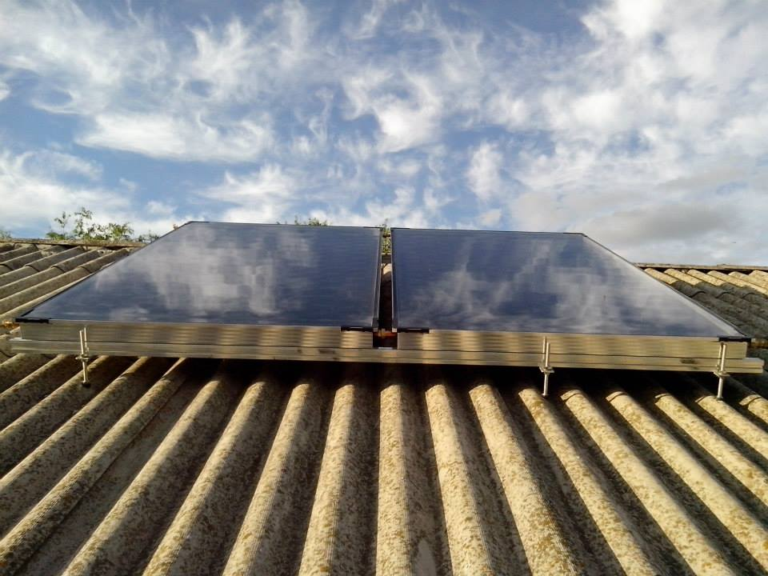

The CBA Project in Donetska Region: Factsheet

The largest cities and towns of the region are Donetsk, Mariupol, Makiivka, Horlivka and Kramatorsk.

Donetsk region is highly industrially developed. It has fifth part of the Ukrainian industrial potential. Ferrous metallurgy, fuel industry and power industry are in demand in the structure of industry production. The oblast has also developed transport infrastructure. The area is also rich in fertile soil and fits for agriculture.

Donetsk region is a south-eastern part of Ukraine. It borders with Russia on the east and such Ukrainian regions as Luhansk, Kharkiv, Dnipropetrovsk and Zaporizhia. It has also access to Sea of Azov. Donetsk region territory occupies 5.4% of the total area of Ukraine with a population of about 4.3 mln. About 91% of the region population lives in cities and towns.

Donetsk oblast includes 18 rayons, 52 cities, 131 urban villages, 1,118 villages.

**Donetsk region background**

KEY DATA ON THE CBA-I and CBA-II PROJECT IN DONETSK REGION

Updated 20 May 2016

Beneficiaries

135,450 men, women and children

The CBA Microprojects in Donetsk region

78 schools/kindergartens

15 health posts

8 water supply

8 street-lightning

The CBA-II Coverage in Donetsk Region

**The CBA Implementation in Donetsk Region**

Implementation of the first phase of the CBA Project commenced in Donetsk region during March 2009. First phase was succeeded by a second phase in July 2011. Over these two phases 135450 of men, women and children of the region have benefitted from improvement in 78 schools/kindergartens, 15 health posts, 8 water supply, 8 street-lightning and so on. This happened through joint effort of the citizens, oblast/rayon/local level governments, CBA Project and the private sponsors.

**Energy Efficiency in Donetsk oblast**

***Third phase of the CBA III*** was initiated in Donetsk region with regional launching and signing of MoU which took place on November 13th, 2014. The region received a quota of 8 rayons for standard\replication components.

Rayons selected for the CBA-III: *Artemivskyi, Kostiantynivskyi, Velykonovovasylkivskyi, Slovianskyi, Krasnoarmiiskyi, Krasnolymanskyi, Dopropilskyi, Oleksandriiskyi.*

***Micro project approved as of 20 May 2016:*** *30 micro projects (5 – health, 12 – energy saving, 1 - water supply, 1 – rural economic development).* Around 95,400 persons will benefit from implementation of these initiatives. Total budget for the initiatives is approx. UAH 6.8 mln (USD 306,300). The UNDP will provide around UAH 4.7 mln (USD 211,700).

3 cities supported for partnership in the CBA-III within the framework of the urban development component – *Artemivsk*, *Dobropillia* and *Dymytrov*.

*Microprojects approved as of 20 May 2016*: 39 micro-projects (17 in Artemivsk, 14 in Dobropillia and 8 in Dymytrov). Around 8,000 persons will benefit from implementation of these initiatives. Total budget for the initiatives is around UAH 8.914 mln (approximately USD 329 ths). UNDP will provide approx. UAH 4.5 mln (more than USD 203 ths).

**UNDP/CBA support for Internally Displaced Persons**

The CBA Project supported 3 microprojects in Donetsk region: reconstruction of health resort “Slovyanskyi” in **Slovyansk** city; and renovation of Donbas interregional Centre of vocational rehabilitation for disabled persons in **Kramatorsk** city. 655 persons benefited from these initiatives.

[www.cba.org.ua](http://www.cba.org.ua)

20 Esplanadna Str., office 704-708, Kyiv Tel: +38 (044) 253 5975 Facebook: www.facebook.com/cbaproject

**CBA Community** **Development Officers, Donetsk Region**

**Natalia Osypenko**

**mob. tel.: (050) 381 44 39**

**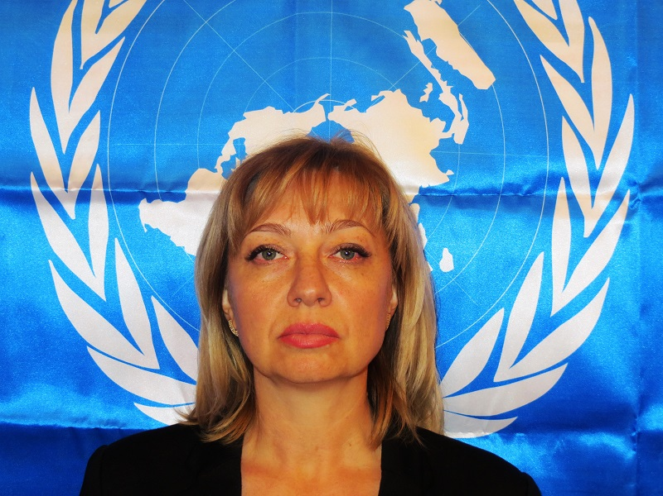**

**Nelia Dashkovets**

**mob. tel.: (050) 381 44 52**

**