Z:\All folders 2014\COMMUNICATION UNIT\LOGO_2014 and letter heads\undp_logo_new_eng_96dpi.jpg 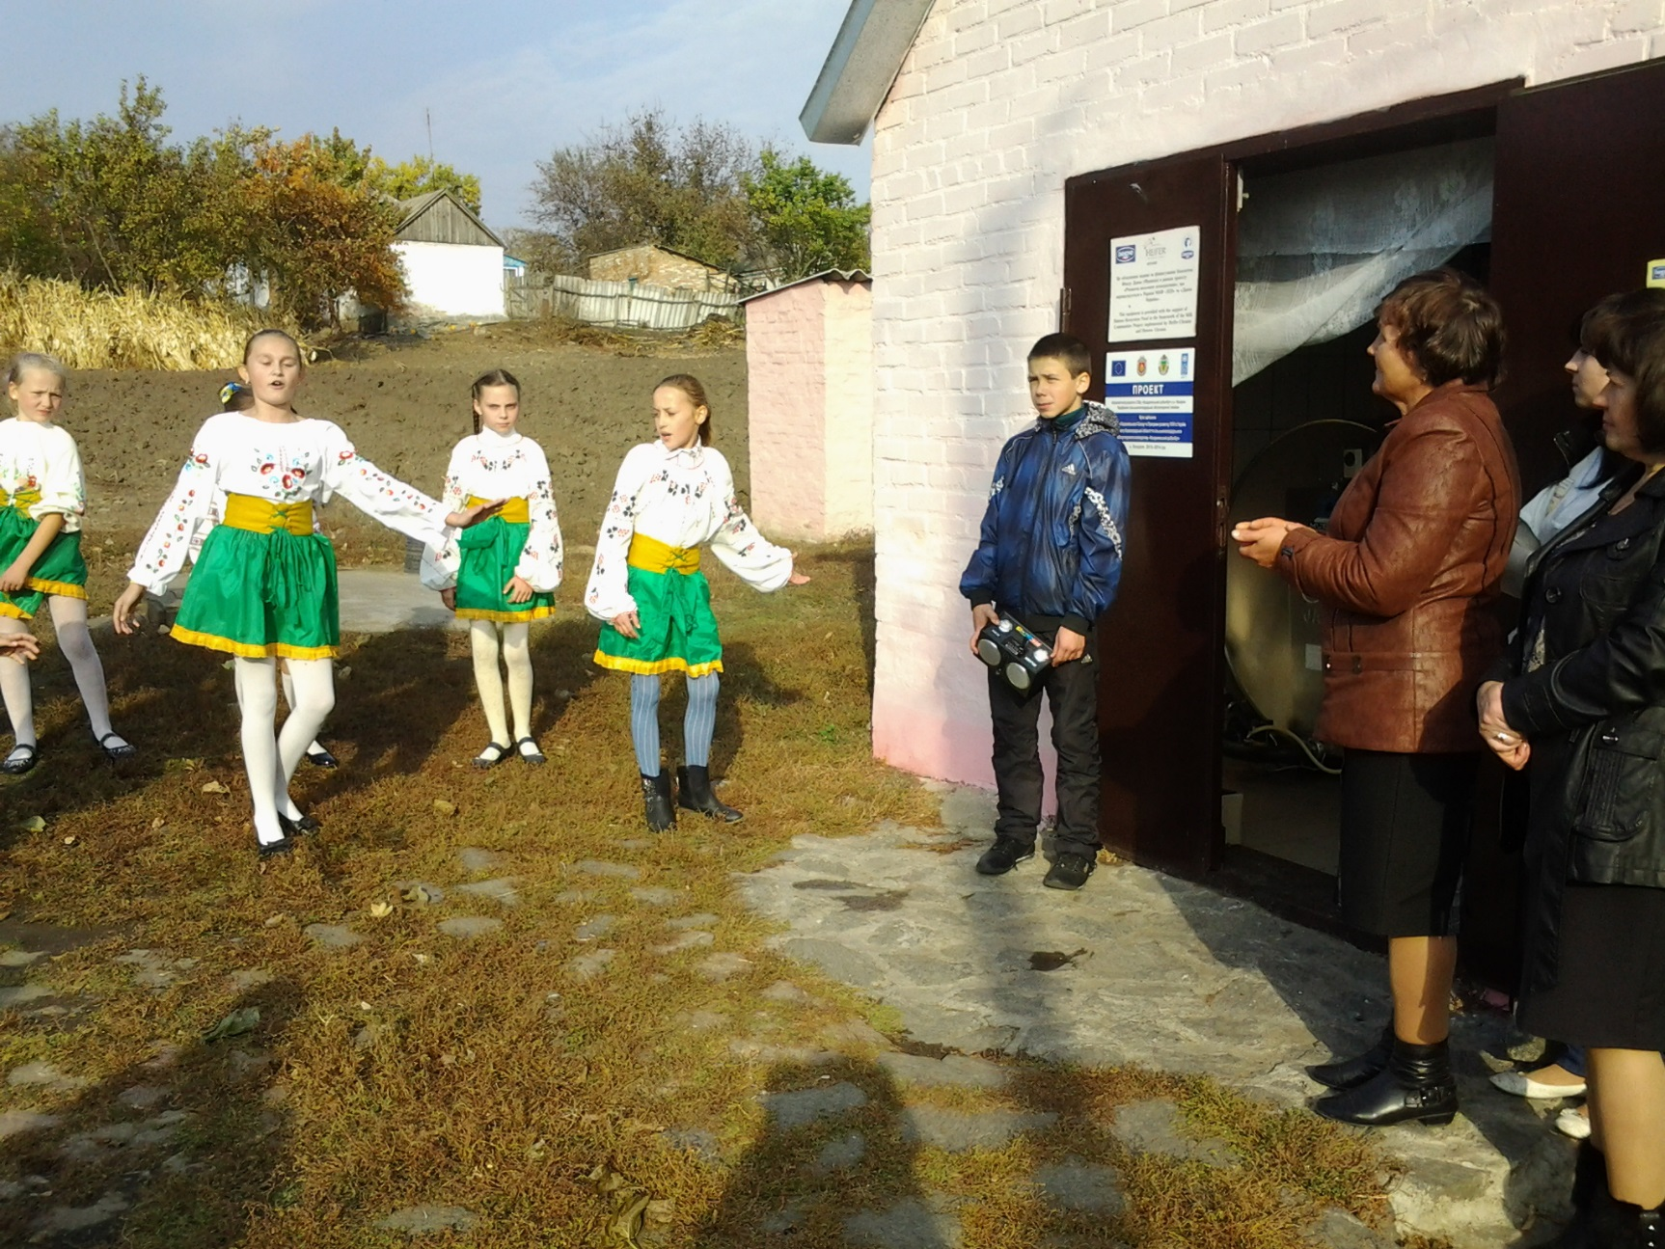

In the structure of processing industry with the share of 69% in the general production volumes, the share of machine-building industry makes 22.1 % as well as food industry – 33.9 % and construction materials industry – 5.3 %.

Among powerful industrial enterprises there are State Holding Company "Oleksandriyavugillya" (extraction and processing of brown coal is the main type of its activity) and two unique complexes on extraction and production of nickel and graphite: the Liability Limited Company "Pobuzke Ferronickel Plant", Joint-Stock Company "Zavallivsk Graphite Integrated Works" and branch of the National Center for Atomic Energy Development.

nt.

CBA Project in Kirovohradska oblast:

Factsheet

Kirovograd Region is situated in the centre of Ukraine. The administrative center of the oblast is Kirovohrad city. The area of the oblast is around 24,600 km2 with population around 1.1 million. The Kirovohrad Oblast is administratively subdivided into 21 rayons (districts) as well as 4 cities (municipalities)

The region is represented by production of sowing, soil cultivation and harvesting machines, bridge electric cranes, mining briquettes, nickel, graphite, mountain beeswax, sewing wares, and also wide range of products of food industry.

In the structure of processing industry with the share of 69% in the general production volumes,

KEY DATA ON CBA-I and CBA-II PROJECT IN KIROVOHRADSKA OBLAST

**Kirovohradska oblast background**

Beneficiaries

80300 men, women and children

CBA Microprojects in Kirovohradska oblast

80 schools/kindergartens

12 healthposts

8 water supply

1 environment

4 rural economic development

Updated 6 Jan 2016

**CBA-III Estimated Budget in Kirovohrad Oblast**

CBA Project will provide around USD 360 ths to support implementation of local community initiatives

(USD 40 ths for each rayon).

**CBA I and CBA – II in Kirovohradska Oblast**

Implementation of the first phase of CBA Project commenced in Kirovohrad region during March 2008. The second phase of the Project was launched in July 2011. Over these two phases 80,300 of men, women and children of the region have benefitted from improvement in 80 schools/kindergartens, 12 healthposts, 8 water supply, 1 environment, 4 rural economic development, 6 school buses and so on. This happened through joint effort of the citizens, oblast/rayon/local level governments, CBA Project and the private sponsors

**Third Phase of the Project**

***Third phase of CBA III*** was initiated in Kirovohradska oblast with regional launching and signing of MoU which took place on 15 October 2014. The oblast received a quota of 9 rayons for standard\replication components.

Rayons selected for CBA-III: *Znamianskiy, Novomyrgorodskiy, Novoukrayinskiy, Oleksandrivskiy, Oleksandriyasky, Vilshanskiy, Kirovogradskiy, Novgorodskiy and Petrivskiy rayons.*

***Microprojects approved as of 6 January 2016****:* *24 micro projects (16 – energy saving, 1 – water supply, 5 – energy efficiency, 2 – business start-ups).* Around 32,000 persons will benefit from implementation of these initiatives. Total budget for the initiatives is approx. UAH 9.5 mln (approx. USD 428,000). UNDP will provide around UAH 6 mln (approx. USD 270,300).

During the Third Phase of the CBA Project it is also expected to create 4 agricultural service cooperatives in two rayons of Kirovohradska oblast – Znamianskiy and Novomyrgorodskiy.

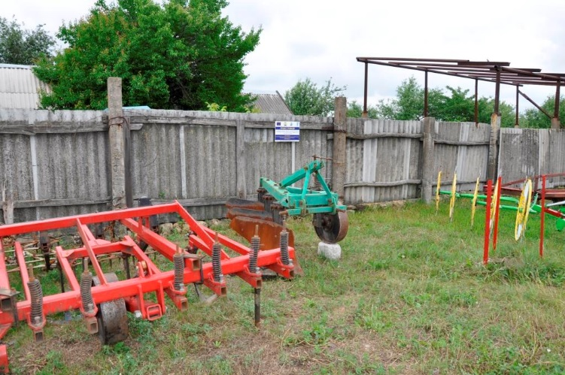

[www.cba.org.ua](http://www.cba.org.ua)

20 Esplanadna Str., office 704-708, Kyiv Tel: +38 (044) 253 5975 Facebook: www.facebook.com/cbaproject

**CBA Community** **Development Officers, Kirovohradska oblast**

Tetyana Golovchenko

Mob. tel.: (050) 417 71 57

tetyana.golovchenko@undp.org

**[](http://cba.org.ua/images/stories/Foto_CBA_staff/Regions/Golovchenko.jpg)**

Olena Radul

Mob. tel.: (050) 386 91 99

olena.radul@undp.org

**[](http://cba.org.ua/images/stories/Foto_CBA_staff/Regions/Radul.jpg)**

Valeriy Nikolenko

Driver

Mob.tel.: (050)387 45 98

**[](http://cba.org.ua/images/stories/Nikolenko.JPG)**