Draft



EU/UNDP

Community Based Approach to Local Development Project

Second Phase

Operational Manual on

IMPLEMENTATION OF ENERGY EFFICIENCY COMPONENT

(For Regional Implementation Units,

Community Organisations and Local Partners of CBA)

June 2012
Disclaimer Page

Concept: Oksana Remiga
Writing: Jaysingh Sah, Oleksandr Baskov
Contributors: Oleg Baranetsky, Oleksandr Karnaukh, Oleg Rogozin, Nikolay Kolomiets, Denis Poltavets, Elena Ruditch

Abbreviation
ACMB | Association of Co-owners of Multi-Storey Building |  | GDP | Gross Domestic Product
ARC | Autonomous Republic of Crimea |  | LDF | Local Development Forum
BSP | Bodies of Self-Organisation of Population |  | MP | Micro-Project
CBA | EU/UNDP - "Community Based Approach to Local Development" Project |  | MPP | Micro-Project Proposal
CC | City Council |  | NERC | National Electricity Regulatory Commission Of Ukraine
CDF | Community Development Fund |  | NGO | Non-Government Organization
CDP | Community Development Plan |  | O & M | Operation and Maintenance
CDP | Community Development Plan |  | ODF | Organizational Development Fund
CHP | Combine Heat and Power |  | OMF | Operation and Maintenance Fund
CMT | Community Mobilisation Team |  | PAS | Participatory Assessment System
CO | Community Organisation |  | PMU | Project Management Unit
CO-MT | CO-Management Team (CO Executive Body) |  | R&D | Research and Development
Co-op | Cooperative |  | RCC | Regional Coordination Council
DEC | Display Energy Certificates |  | RES | Renewable Energy Sources
EE | Energy Efficiency |  | RSA | Rayon State Administration
EEP | Energy Efficiency Passport |  | TD | Technical Document
EU | European Union |  | UNDP | United Nations Development Programme
FG | Functional Group |  | VC | Village Council

Table of Content
Ch. | Content | Page
1 | INTRODUCTION
1.1 | Global Energy Problem | 1
1.2 | National Energy Problem | 2
1.3 | What about Ukrainian Villages? | 3
1.4 | What Can Ukrainian Villagers Do? | 4
1.5 | Whither to Act Individually or Collectively? | 4
1.6 | How Can CBA Project Support? | 4
2 | TECHNOLOGY IN RURAL ENERGY SECTOR
2.1 | Innovative Technology | 6
2.2 | Alternative Technology | 6
2.3 | Renewable Energy | 7
2.4 | Forms of Innovative Technology in Energy Sector | 7
2.5 | Service Providers | 8
3 | PARTICIPATION PROCEDURE
3.1 | Launching Regional Awareness | 9
3.2 | Selection of Regions for Special Piloting | 9
3.3 | Selection of Regions for Piloting Renewable Energy Technology | 10
3.4 | Selection of Rayons for Enhancing Energy Efficiency | 10
3.5 | Eligibility of Communities for Local Action | 10
3.6 | Mainstreaming of Community Development Plan | 10
3.7 | Selection of Community Priorities for Support | 11
4 | IMPLEMENTATION OF ENERGY EFFICIENCY PROJECT
4.1 | Form Capable Functional Group | 12
4.2 | Develop Technical Design And Cost Estimates | 12
4.3 | Develop Detail Proposals | 13
4.4 | Approval of Micro-Project Proposal | 13
4.5 | Project Implementation | 14
4.6 | Post Project Completion Activities | 15
 | ANNEXTURES
I | Legislations on Energy Efficiency and Alternative Energy Sources | 16
II | Brief Description about CBA Project | 18
III | Details on Various Forms Technologies on Energy Efficiency | 20
IV | Details on Various Forms Technologies on Renewable Energy | 23
V | Categories of Energy By Source and Technology | 33
VI | Contact Information of Service Providers | 34
VII | Rayon Application Form | 38
VIII | CBA Methodology for Competent CO Development | 40
IX | MP Idea | 43
X | Simple Proposal Format | 46
XI | Proposal MP Idea Evaluation and Ranking | 47
XII | Description about Energy Efficiency Passport | 48
XIII | Micro-Project Proposal Form | 52

Chapter – 1
INTRODUCTION
Preamble
Citizens and authorities in rural Ukraine are faced with lack of energy supply or inefficient energy supply system thereby affecting their living condition. Government policy promotes renewable energy and innovative/efficient energy technology appropriate and affordable for these areas. Several factors hinder this vision of the government including lack of awareness and skill at local level. CBA Project aims to enhance local capacity by enabling citizens and local authority to learn about these technologies and use them jointly to solve their energy problem in a sustainable way. This manual offers examples of currently available innovative technologies appropriate for rural communities and a set of process to be followed by citizens and authorities to make use of these technologies through joint and collective action. It also spells out the role of CBA Project in support of their endeavours.

Global Energy Problem |  | National Energy Problem |  | What About Ukrainian Villages? |  | What can Ukrainian Villagers Do? |  | Act Individually or Collectively? |  | How can CBA Project Support?

1.1 Global Energy Problem
A large part of global energy comes from fossil fuel. It creates various forms of pollution causing threat to climate and health of the living beings on the planet due to global warming. Through various international covenants, there is a pressure on governments to reduce pollution and promote green energy. European countries are fore-runner in this direction. They have developed clear vision, strategy and legislation to curb pollution and greenhouse gas emission. They have also determined to raise the share of renewable energy from 10% in 2008 to 20% in 2020. Ukraine is trying to follow the global environmental movement too and now it is one of the countries that have contributed to reduction of greenhouse gas emission to mitigate global warming.
Table - I: Source of Energy Use in Ukraine and Other Countries (%)
 | World | Ukraine | EU-15 | USA
Natural gas | 21 | 39 | 24 | 23
Oil | 33 | 12 | 37 | 39
Coal | 27 | 28 | 18 | 24
Uranium | 6 | 18 | 13 | 9
Renewable energy sources (RES) | 13 | 3 | 8 | 5
Total | 100 | 100 | 100 | 100
Source:
- Renewables Information 2010; www.iea.org/publications/free_new_Desc.asp?PUBS_ID=2037;
- EU energy and transport in figures, 2010 www.eurotrib.com/story/2010/5/28/43128/4067; Ukrainian Statistics Agency http://ukrstat.gov.ua
- Figures are rounded
Several forms of technology and regulatory measures have been put in place globally to minimise the negative impact of continued use of traditional (fossil-based) source of energy. However, supply of fossil fuel (oil, gas) is limited for a few decades unfortunately (for coal, it could go for 1-2 hundred years). Also, it is expected that its price will keep increasing in line with the decline in supply. Thus, there is a serious need to find alternative sources of energy. Nuclear power is one of the alternatives but it is also not without danger. Alternatively, countries could meet their energy need from import. However, inter-country dependency on energy causes conflict from time to time. Thus, scientists across the globe have been striving hard to find the alternative ways of obtaining energy which is safe and sustainable. They have achieved success to some extent. Their success appears in terms of ‘renewable energy’ which has several forms such as solar energy, wind energy, hydro-energy, bio-energy and so on. Renewable energy is considered to be green. It is available from nature, does not cause environmental damage (or its negative impact on environment is minimum), is available everywhere and for ever. That’s why it is sustainable.
Apart from renewable energy, scientists have also made achievement in terms of making technological breakthrough thereby raising efficiency of traditional energy technologies so that the same level of energy could be produced with lower pollution, with smaller quantity of fuel (input) and with minimum energy loss.
1.2 National Energy Problem
Ukraine is one of the most intensive energy consuming countries in the world. It consumes 2.2% of world’s energy with less than 1% of the world’s population it has. One of the reasons for its high energy consumption is existence of old technologies (or energy infrastructures) throughout Ukraine which are worn-out and have become highly inefficient. They cause energy loss to about 30%. Repairing or replacing of these technologies will be very costly and time taking.
Chart - I: Energy Source in Ukraine
Source: National Report on Implementation of the Energy Efficiency State Policy, 2009
http://ukrstat.gov.ua
Plants and natural reserves (such as coal mine, underground oil and gas reserves) form key energy source for Ukraine. They share 79 % of national energy production followed by nuclear energy which shares about 18%. Alternative/renewable energy sources (e.g. water, wind, bio-gas, solar etc.) are still at infancy as they produce only 3% of the total energy produced in the country despite the fact that this source possesses tremendous potential in Ukraine.

Chart - II: Energy Balance in Ukraine
Source: Energy balance 2010 for Ukraine. http://ukrstat.gov.ua
From its own energy sources, Ukraine meets only 61% of the energy need with 39% deficit, which met through import. From time to time, this energy dependency on other counties results in serious threat to economic growth and national security. As a result, there is a serious need to look for alternative arrangements to reduce this dependency, especially in light of its depleting natural resources; disastrous accident of Chernobyl nuclear power plant and its commitment to Kyoto protocol to reduce pollution.
Ukraine has developed clear long term vision and strategy to deal with its energy sector. Energy Strategy for the period until 2030, set by the Cabinet of Ministers, outlines strategic objectives for energy sub-sectors to enhance the country's overall economic development and the people's well-being. Key strategies includes -
- Creating conditions for a sustainable and high quality energy supply
- Ensuring reliable and sustainable functioning of the energy industry
- Reducing dependency on energy import
- Reducing energy intensity
- Reducing environmental impact and ensuring civil safety
The Energy Strategy specifies that Ukraine will increase the production of energy from renewable and non-traditional sources from 4% (including 3.2% big hydropower) in 2005 to 19% in by 2030. Accordingly, state programmes for the development of renewable, non-traditional and secondary sources of energy have been initiated in the Ukrainian. Within framework of the same, regional authorities, rayon authorities and local councils across the country are in a process of developing long term energy strategy and implement such strategies on their own or with support from various public/private agencies.
Program of Energy Efficiency and Renewable Source of Energy 2010-2015 expects -
- Implementation of new technologies of production and consumption of energy resources, cogeneration technologies and technologies that involve the use of heat pumps, electro-accumulative heating and hot water supply;
- Utilising solar energy and geothermal energy;
- Extraction and utilisation of gas (methane) from coal deposits and shale gas as alternative fuels;
- Production and use of biofuels;
- Development of wind energy, small hydro and bioenergy;
- Modernisation of gas transportation system, systems of heat and water supply, power plants and cogeneration plants;
- Implementation of measures to reduce energy consumption held by the state budget institutions;
- Reduction of environmental pollution;
- Restructuring of enterprises, aimed at reducing material and energy intensity of production;
- Raising public awareness about efficient use of energy resources through the media, education programs, and creation of regional information centers.
To put these strategies into effect various legislations have been promulgated from time to time as described in Annex – I. Special provisions have been made in terms of registration, taxation, tariff, subsidies and so on. Thus, scope of alternative/renewable energy is expected to gain momentum in Ukraine in years to come. Biggest expansion is expected in exploitation of wind energy followed by solar energy, agricultural waste, wood, water, bio-gas and others.
1.3 What about Ukrainian Villages?
Several Ukrainian villages (especially those which are located away from main supply line and their population size is very small) are not connected with gas supply and several of them have highly inefficient heating system in public buildings and in private houses – causing them to pay more tariff but remain under-served. Villages located far from market centres spend more on transportation of agricultural inputs and outputs and for buying consumption goods. It is because local cost of fossil fuel (imported from distant towns) becomes costly resulting into higher cost of transportation and operation of agricultural tools (e.g. tractor, pumpset, harvester, thresher etc.). Consequently, income of rural families and hence their living standard is severely affected.
Various legislations of the Government on energy and alternative energy provide rooms for addressing energy issues of small rural Ukrainian communities. Energy production through small and micro level devices (with capacity of 10 MW or less) does not require registration, taxation and connection with grid only in case of own generation and consumption and require to meet construction standards.
According to the State Statistics Committee (2009), hot water is available to 30% households in rural areas compared to 88% of urban areas; gas supply is accessible to 50 % of rural households versus 84% of urban households. More than 20% of the boilers at community heating facilities have been in use for more than 20 years, of which 38% are obsolete and extremely inefficient. About 32% of the pipes in heating networks and 30% of heating facilities need replacement. Overall, the quality of energy service provided in rural areas remains poor and inefficient (e.g. heating is provided at a very high cost due to the wasted energy, and water leakage).
The amount of energy consumption of the Ukrainian households is 3-7 times higher than the average in Europe. Key reasons include not only obsolete energy producing/supplying equipment but also the old buildings which cause large amount of energy loss through poor quality of roof, window, walls and floor. Since energy costs now constitute more than half of all residential service costs, any increase in energy price will lead to a significant stress on the family budget especially for middle and low-income households.
1.4 What Can Ukrainian Villagers Do?
Thanks to technological development, several technologies are available now to improve efficiency of current energy production/insulation devices and to exploit alternative energy sources. The technologies are available in small, medium and large size for consumers to choose from subject to their need and budget.
Thus, solution to energy problem in remote rural part of Ukraine lies in adoption of energy efficient technologies and alternative sources of energy production.
1.5 Whither to Act Individually or Collectively?
Some of the energy saving technologies are good for small private houses and therefore house/apartment owners can install such technologies on their own. However, it is collective action which makes a bigger impact – especially when the matters comes for public/community level services or when most of the community members happen to be of low income category and cannot afford to install technology in their individual capacity.
1.6 How Can CBA Project Support?
Community Based Approach to Local Development (CBA) Project (finance by European Union and co-financed and implemented by United Nations Development Programme) has demonstrated at national level that when people in organised form and local authorities come together, delivery of communal services becomes easier and sustainable. CBA Project desires to assist citizens of rural areas to achieve the vision of energy efficiency through collective action. It provides technical and financial assistance to Ukrainian authorities and rural Ukrainian communities such that they can improve energy situation in their community. Key supports include –
- Energy efficiency strategy development
- Seed grants for implementation of community initiatives
- Establishment of institutional mechanism (for joint decision and collective actions);
- Training, roundtables, workshop and exposure visits – for raising awareness and skills;
- Advocacy/motivation for psychological preparedness – to come together and to act together;
During first phase of CBA Project, partner communities expressed need for addressing energy efficiency issue. That’s why second phase of CBA focuses on supporting energy efficiency technologies and renewable energy sources.
This will be done through two approaches: normal piloting and advanced piloting. The first one includes increased CBA-cost sharing for micro-projects related with innovative energy efficiency technologies and renewable energy sources as described in Chapter-2 and Chapter-3. Advanced piloting includes support for regional energy strategy development/updating and technical documentation besides the support for micro-projects that fall under category of normal piloting,
Chapter – 2
TECHNOLOGY IN RURAL ENERGY SECTOR
Innovative Technology |  | Alternative Technology |  | Renewable Energy |  | Forms of Innovative Technology |  | Service Providers

Energy efficiency component of CBA-II will support innovative energy efficiency and renewable energy technology. Brief explanation of term ‘Innovation’ and its types is given below:
2.1 Innovative Technology
Innovation is the new version of something which is already in use. It expands the level of use. Three types of innovative technology take existing technological knowledge to a new level, namely –
- Incremental Innovation: It is a small change but causes valued improvement in a product or method. Use of plastic-framed glass windows in place of traditional wood-framed glass windows in buildings can be considered as incremental innovative technology.
- Semi-radical Innovation: It relies on existing technological knowledge, but uses that knowledge in a way that differs significantly with the past. For example, agricultural products can not only be used for food but also for fuel production (biogas, bioethanol, biodiesel). Technology for production of bioethanol and biodiesel is similar to that of petrol and diesel production even though bio-products are used as input for the former while oil is used for petrol and diesel. Biogas is production could be considered another example. Overtime, there has been several adaptation in design and equipment for higher efficiency and wide usage making the technology innovative.
- Radical Innovation: it involves a shift from the previous technology by providing new and often more accessible products or methods. Use of solar power or wind power in producing electricity or use of geothermal power for air-conditioning of homes.
So in case of innovation we can speak of those technologies that provide something new to existing (traditional) technology. In other words innovative technology is alternative one to traditional. More about alternative technology is considered in the next section.
2.2 Alternative Technology
In general, alternative technology means alternative to traditional technology. This term is provisional and depends from time and place of definition. Example, in the past radio was alternative technology of mass media to newspaper, than television became alternative to both radio and newspaper, and now internet is alternative to all mass media. According to energy carrier: in the past coal was alternative to firewood and peat, then oil became alternative to coal, uranium to oil, natural gas to uranium and oil, and now renewable energy is alternative to all fossil fuel. That is why for now manufacturing or production method that is less polluting and more resource efficient than the traditional methods is considered as alternative technology. In case of energy sector (with production, supply and consumption of energy), it is reflected in term of ‘energy efficient technology’. Details about specific energy efficient technologies are given in Annex – III.
2.3 Renewable Energy
Renewable energy refers to a source of energy production that does not depend on fossil fuels or nuclear power to operate. Sun, wind, water, earth, bio-mass (from plants, animals, industry etc.) are some sources of renewable energy.
Common form of ‘renewable energy technologies’ are biogas plants, solar accumulator, photovoltaic cells, wind turbine, water turbine, sewage processing plant etc. Details about technologies under this category are given in Annex –IV.

Legislation of Ukraine in the Sphere of Renewable Energy Sources (No. 555-IV “On Alternative Sources of Energy 20.02.2003 - Article 1”) contains definitions of “alternative sources of energy”, “alternative energy”, “alternative energy facilities”, and “sphere of alternative energy”. Under this Law, alternative sources of energy include renewable energy sources such as solar energy, wind energy, energy from the seas (wave and tidal), rivers, biomass, geothermal energy and “secondary energy resources that exist constantly or are periodically generated in the environment”. Energy equipment is considered to be alternative if contribution of renewables is not less than 50% of installed capacity.
2.4 Forms of Innovative Technology in Energy Sector
Innovative technologies in energy sector can be viewed from various perspectives (e.g. by type of energy produced or by source) and classified into two categories:
- Energy saving type - energy saving plastic windows, doors and energy saving light bulbs and insulation of roof and facade are examples of this category (this kind of technology is supported by CBA under usual communal infrastructure micro-project);
- Energy producing – efficient boilers, solar accumulators, bio-fuel producing machine are some examples of energy producing technology (this kind of technology alone or together with energy saving type, is considered to be innovative energy efficiency and/or renewable energy technology and will support under second phase of CBA Project).
Innovative energy producing technologies can also be classified as follows in terms of fuel (energy source) they use for operation (more detail given in Annex – V):
- Fossil fuel (natural gas) based –
  - Condensing boiler: This boiler has an increased efficiency over the more traditional boiler due to the extraction of heat from the otherwise wasted flue gases;
  - Cogeneration unit: is a generator that produces both heat and electricity;
- Renewable energy based-
  - Solar Collector: a device which uses solar power for heating;
  - Photovoltaic module: is a photoelectric converter that can convert solar electromagnetic radiation into electricity;
  - Wind turbine: This is a device designed to convert wind energy into electricity;
  - Pyrolysis boiler: a modern solid fuel (biomass) boiler which could utilize low quality biomass with small pollution level;
  - Cogeneration unit: A device that uses biomass as fuel for generation of heat and electricity;
  - Biogas plant: This device produces methane gas from decomposing organic material under anaerobic (lack of oxygen) conditions. The gas could be used for generation heat or electricity (or both) and as fuel for transport;
  - Biodiesel unit: This device uses vegetable oil- or animal fat for generation heat or electricity (or both) and used as fuel for transport;
  - Hydro turbine: This is a device designed to convert water energy into electricity;
  - Heat pump: This device uses geothermal energy (geothermal heat pump), air energy (air heat pump), energy of water and ground for heating and/or conditioning.
- Electricity (from any source) based - Electro-accumulator that uses electric boiler and water heat accumulator for water heating
Innovative energy producing technologies can also be classified as follows in terms of energy they produce:
- Heat Producer-
  - Condensing boiler
  - Electro-accumulator
  - Solar collector
  - Pyrolysis boiler
  - Biogas plant
  - Biofuel unit
  - Heat pump
- Electricity Producer-
  - Solar photovoltaic module
  - Wind turbine
  - Hydro systems
- Heat and Electricity Producer
  - Cogeneration unit
2.5 Service Providers
In Ukraine there are a number of companies which provide local, regional, national level services in the area of alternative energy/renewable energy. Some of them are consulting type while some are related with research and yet some are installer and maintainer. Annex – VI provides list of companies that could be consulted as required.

Chapter – 3
PARTICIPATION PROCEDURE
Launching Regional Awareness |  | Selecting Regions |  | Selecting Rayons |  | Selecting Communities |  | Community Energy Planning |  | Selecting Micro-Projects

The special energy efficiency package will be available to all regions of with varying degree of support to them subject to pre-defined set of criteria. Participation of the regions is voluntary as they may chose not to participate even if they are eligible.
3.1 Launching Regional Awareness
Orientation session will be held in each region to familiarize the CBA partners about energy efficiency component of CBA. CBA representatives will explain details about the characteristics of this component and terms of participation to the participants of the session. Participants include leadership of oblast authorities and partner rayons; officials of oblast and rayons related with alternative/renewable energy and CBA focal persons; private sector related with alternative/renewable energy and media. This event could be included in regular RCC meeting of CBA or during regular meeting of the regional authorities.
3.2 Selection of Regions for Advanced Piloting
Six regions will be selected through competition for comprehensive piloting of energy efficiency. The pilot regions will represent (a) geographical diversification with rich in more than one form of renewable energy source, (b) high degree of per capita CO2 emission, (c) high level of commitment to promote and support energy efficiency in rural area (including through renewable energy sources) reflected in their existing energy strategy, regional energy plan, and budget allocation or reflected in its social-economic program of regional development (d) level of realization of plans under mentioned program in the past, (e) strong necessity of improving the energy strategy to match the commitment (of the regional authority) and opportunities, (f) level of technical capacity (expertise) of the regional authority to pursue energy efficiency vision, (g) existence of analysis of ‘local/renewable energy sources’ appropriate for rural areas, (h) existence of the list of budget objects with technical and maintenance information, and (i) performance of the region in implementing CBA methodology.
The selected region will be supported in following terms:
- Support, on cost sharing basis, to update/improve the existing energy strategy;
- Support, on cost sharing basis, to prepare technical documentation for major investment in energy sector, as reflected in the updated energy strategy document;
- Support, on cost sharing basis, to pilot up to 8 micro-projects in selected communities through renewable and innovative energy technologies;
- Support for experience documentation, dissemination and advocacy

3.3 Selection of Regions for Normal Piloting
All 19 regions (except the 6 selected as per 3.2 above) will be eligible for receiving CBA support for normal piloting on innovative energy efficiency and renewable energy technologies. A competition will be conducted to allocate quota of up to 6 micro-project support based on –
- Potential of at least one form of renewable energy source;
- Level of commitment to promote and support energy efficiency and renewable energy in rural areas;
- Availability of energy strategy and regional energy plan with emphasis on rural areas;
- Level of commitment for supporting renewable technology reflected in availability of special program and budget for rural areas;
- Performance of the region in implementing CBA methodology.
3.4 Selection of Rayons for Enhancing Energy Efficiency
After selection of regions for advance piloting and after allocation of quota for normal piloting, rayon competition will be set in each region. All rayons (including rayons under replication) which are partners of CBA will be eligible for participation in the competition for energy efficiency grant. Pre-defined number of rayons will be selected for support based on following criteria:
- Potential of renewable energy sources in the rayon;
- No. of rural communities lacking gas supply;
- No. of rural communal infrastructures facing serious energy inefficiency;
- Availability of special programme & budget to exploit renewable energy opportunities;
- Level of technical capacity (in term of human resource) to work on renewable energy sector;
- Level of pro-activeness (performance) in implementing CBA methodology
Sample application form for competition is given in Annex - VII
3.5 Eligibility of Communities for Local Action
After selection of rayons, competition will be set for community selection. Any community organisation, formed/grafted since June 2011 based on CBA methodology (as described in step 1-5 of Annex - VIII), will be eligible for partnership with CBA Project for implementation of innovative/renewable energy micro-project subject to following conditions:
- It should belong to one of the CBA-rayons selected as per section 3.4 for energy support;
- It should have maintained satisfactory level of maturity as shown by maturity index and PAS score;
- It should have prepared community development plan (CDP) with ‘energy supply’ or ‘energy efficiency’ as the top priority and prepared MP idea (Annex - IX);
- It should have received maximum one micro-project support from CBA and completed it with satisfactory O & M mechanism or must be still in the stage of implementation
- Level of pro-activeness (performance) in implementing CBA methodology

  - Mainstreaming of Community Development Plan
CDP and MP idea developed by the CO ought to be accepted by the local council and presented in the LDF meeting of the rayons selected under section 3.4 above. The LDF-members debate over the CDPs submitted by various COs and approve the ones to be supported under energy support programme. The approval takes into consideration the followings:
- Priority sequence – First priority goes to the COs which are in remote areas and lack energy (gas) supply for cooking and heating followed by the one for community infrastructure with comprehensive coverage (e.g. taking energy production and energy conservation elements into consideration as one project) so that full effect of energy efficiency could be realized and then for community infrastructure with only for renewable energy technology (this programme does not support stand-alone energy saving technology – refer chapter 2, section 2.4);
- Multi-technology is possible (i.e. multi-renewable sources or a combination of regular energy supply source combined with renewable energy source). However, main part of the budget should be dedicated to innovative energy efficiency and renewable energy solutions;
- Availability of fund is there as per the following norms:
- Beneficiary CO … … … … … minimum 5%
- Budget funding (local council, rayon, oblast) … minimum 25%
- CBA Project … …. … … … up to 70% (limited to $ 20,000 equivalent)
- Private sponsors and other donors (if available). However, fund from private sponsors and other donors should not be considered as automatic reduction in the contribution of CO or local authorities. In case reduction is to be considered, then it will be proportional reduction in all parties contribution leaving not less than 5% for CO and not less than 10% for budget money.
- Preparedness for piloting: There should be an understanding among rayon authorities, local council and CO that this support is in form of experiment and will require special testing, documentation and experience sharing;
- Clear institutional mechanism for ownership and operation and maintenance should be there
3.7 Selection of Community Priorities for Support
The Participating rayon authorities should send the community plan and MP ideas selected as per clause 3.6 (above) to oblast/republican community resource centre for regional level competition using the template as given in Annex - X. CBA coordinator in the region will analyse information from each proposal with support of experts at CBA/PMU, as necessary. Based on analysis, the proposals will be ranked (Annex - XI).
An energy proposal selection committee consisting of following members will review the analysis based on criteria mentioned below and select the ones for support.
Composition of Selection Committee
Community Development Specialist/CBA - Chairperson
Energy and Environment Expert/CBA - Member
CBA Focal Person from regional authorities - Member
Energy expert of the regional authorities - Member
Community Development Officer/CBA - Member Secretary

Suggested Scoring Criteria
Social, economic, environmental and
technical feasibility of the proposed scheme 15
Intensity of energy problem in the community 15
Maturity and performance of CO 15
Availability of cost sharing 15
Pro-activeness (performance) of rayon 10
Level of technical guidance availability from rayon 10
Mechanism for operation & maintenance 10
Possibility of further scaling up of the technology 05
Past performance of the CO (during CBA-I/CBA-II 05
Chapter – 4
IMPLEMENTATION OF ENERGY EFFICIENCY PROJECT
Form Functional Group |  | Develop Technical Design and Cost Estimate |  | Prepare MP Proposal |  | Approve MPP |  | Implement MP |  | Post Completion Activities

A community organisation must undertake following steps in order to receive technical and financial support from CBA to undertake support for renewable energy and energy efficiency micro-project. It is to be noted that procedures of energy efficiency component is not all the same as the procedures followed so far in case of communal infrastructure type micro-project. The differences can be noticed here and there in the steps detailed below.
  - Form Capable Functional Group (FG)
The CO whose energy plan is approved at LDF, should form a functional group as described in the CO-manual. Members of the functional group will be trained by CBA Project in the area of renewable energy (concept, technical aspects, existing policy and legislation on renewable energy, implementation mechanism, operation and maintenance, financial management and book keeping etc.). As necessary, they will be exposed to successful site(s) and introduced to possible service providers in this field. Activity of functional group, in general, is the same as described in technical manual and CO-manual circulated by CBA Project.

  - Develop Technical Design And Cost Estimates
With support from technical department of RSA and/or specialised company on alternative energy, the FG participate in ordering of technical design with cost estimate and control it preparing.
The area of renewable energy being relatively new in Ukraine, not much is known about it and technologies related with it. Therefore, the FG must make a thorough search and analysis before making a right selection. Annex – III & IV of this manual provides brief information about some technologies to look at. For detail information and clarification, the FG may contact the companies whose whereabouts are given in Annex- VI.
Compared with "conventional" micro energy-saving (also introduced in the second phase project CBA), preparation of technical document (TD) for energy efficiency components of the Project has its own peculiarities:
- Works under this category of MP should include only a capital reconstruction or even new construction/building. Therefore, the contents of technical document must fully comply with Ukrainian Building Standard # 2.2.3-2004 "Structure, development, coordination and approval of the technical document";
- According with Ukrainian legislation technical design and cost estimate should go through mandatory expertise and energy saving expertise (according with planning measures). Responsibility is lied on the TD designing company and customer of TD;
- When the MP includes measures for energy efficiency in construction building, the solution will be complex. That is, when it covers more than one elements or more than one utilities (such as modernization of heating systems using high-performance heat source, facade insulation, attic insulation etc.), development of TD should be based on energy audits and energy passport of the object which will include information before measures implemented (see Annex XII);
- All works on the implementation of measures envisaged in the TD should be accompanied by supervision of the TD-developer.
If necessary, cost of the technical document preparation could be paid out by CO and/or local authorities as a part of their cost sharing provided the document is prepared/updated after prior approval from CBA or after approval from the LDF meeting is sought for funding. Share of CBA in this task will be up to UAH 3000 provided share of CO and local budget is inadequate to the extent that warrants CBA’s support. Requirement for latest document is necessary to avoid possibility of using old technologies and/or old price rates that are already out of date. The technical design and cost estimate ought to be approved from the general meeting of the CO
4.3 Develop Micro-Project Proposals
FG prepares micro-project proposal with help of CBA-coordinator, rayon focal person and the technical document developed as per in section 4.2 above. CO/FG also obtains recommendation from all sponsors (local, rayon, oblast authorities; private business and memorandum of understanding with object owner for joint operation and maintenance etc.) and collect documents (statute, registration card, bank statement, key protocols etc.). CMT will verifies the proposal and attached document and recommends to PMU for approval.
Relevant format of proposal form is given in Annex – XIII and necessary documents to be attached are given in CO manual or can be obtained from CMT.
  - Approval of Micro-Project Proposal
Experts at CBA/PMU will appraise the proposal and recommend for approval, if found satisfactory. A ‘project approval committee’ makes a final review of the proposal and approves it, if satisfactory.
  - Project Implementation

Following steps are undertaken by the CO in order to implement the micro-project approved by CBA Project:
  - Resource mobilisation: Grant agreement is signed between UNDP and the CO for implementation of the approved micro-project. This event is held in presence of general members so that they become aware of terms and conditions mentioned in the agreement. Following to agreement, CBA disburses grant amount in the account of CO in three tranches as described in detail in the CO-manual and Technical Manual of CBA. Three tranches take place in following conditions:
    - Tranche 1: 20% of the Agreement amount as advance to start the implementation;
    - Tranche 2: 70% of the Agreement amount upon successful utilisation of Tranche-1;
    - Tranche 3: 10% of the Agreement amount upon 100% completion of the micro-project (including from the contribution of all sponsors)
  - Procurement of goods and services: Following receipt of first tranche from UNDP, FG prepares workplan, calls tender, identifies the most potential contractor, gets the contractor selection approved by the general meeting of the CO and assigns the task of implementation to the contractor under the framework of contractual arrangement. CO, local authorities and other sponsors will provide their share of the cost as the implementation proceeds. While procuring goods and services, the CO must follow financial and technical norms of CBA/UNDP.
  - Work implantation and control: The selected company will carry out tasks as described in the contract and proves this by acts of the works. The CO should control quality and quantity of the implementation. Also, CO should make its non-cash contribution as mentioned in the proposal. Details on this subject are provided in the technical manual of CBA. After finishing the works TD designing company should check all works and provide changes in the energy efficiency passport if necessary.
  - Monitoring and reporting: A rayon level Quality Supervision Committee will actively monitor the implementation and will recommend for corrections/release of tranches from CBA, as necessary. The CO should report to CBA about the physical and financial progress in the prescribed format.
  - Donors’ visibility: The CO should acknowledge the contribution of various donors in a visible way. Key contributors are EU, UNDP, village/city council, rayon and oblast authorities, private sponsors and the CO itself. At the outset of micro-project implementation, the CO should establish temporary visibility while a permanent visibility should be made upon completion of the micro-project.

  - Post Project Completion Activities
- Public audit/commissioning and handover: Public audit and commissioning of the micro-project should be conducted by the CO to ensure clearance of the task from the general members and local authorities. In most of the cases, the micro-project will create new object. The resulting object should be handed over to the concerned local authorities. Where possible and necessary, the CO should accept the property on its own balance.
- Ensuring sustainability: Operation and maintenance of the micro-project will be a tricky challenge for the community. It should run like a business and therefore the sustainability mechanism should be developed and practiced accordingly irrespective of who (the local council or the CO) owns the property (Box – I offers some options).
- Experience documentation and dissemination: The CO should document its experience of implementation MP by making a comparative assessment of pre and post project situation. If prescribed by the Project, it shall conduct energy audit once again and compare the result with the one conducted at the outset. One year past after object commissioning CO should order energy audit and energy efficiency passport preparation in certificated organization. The findings should be documented and published in local newspapers and disseminated through other local media, and send to CBA. The CO should also be willing to present its experience in the LDF and share its experience to visitors who will visit the CO to learn from its experience.
Box – I: Some Options of Sustainability Mechanism

Case - I: Cooperative Form: This mechanism is useful when the object of the micro-project (such as community bio-gas) is for the use of community as a whole and not only for public buildings then it should be managed in a business modality. Non-profit cooperative form (or ACMB form) allows the community to own the object, generate income, make expenses and ensure smooth service delivery. All activities to be carried out under the decision of the members. In case of the bio-gas plant, the community can run it as a business in following manner:
- Expenditure – (a) purchase of animal manure from community members (as per defined rate); (b) cost of local technician; (c) cost of micro repair and maintenance of the plant
- Income – (a) sale of the gas to community members (as per defined rate and quantity used); (b) sale of manure to the community members
From above, it is clear that once the bio-gas plant is operational, it does not require voluntary action (e.g. free contribution of manure and free use of gas) rather it can run truly like a private company.
Case – II: Combined form: The CO may under take the micro-project as a non-profit public organisation and establish an associated business to run the system with due income and expenditure but in a non-profit manner.
Case-III: Contractual Arrangement: The CO may contract out the O & M task to (a) a private entrepreneur created out of the CO-members or (b) a private energy company available in the locality. The private owner will run the system under control of the service users (i.e. the CO-members).
Case - IV: Non-profit public organisation: The CO may complete the micro-project in form of NGO; handover the object to its owner (local council, health department, education department etc.) but signs a contract with the owner for sharing the responsibility of operation and maintenance of the system. In this situation it will collect operation and maintenance fund (OMF) from its members regularly and keep in reserve. Whenever maintenance is required, it will contribute out of this reserve. This mechanism allows the CO to have a say in selection of private company, setting of price and assessing quality of service jointly with the owner.

Annex – I
Legislations on Energy Efficiency and Alternative Energy Sources
1. Law “On Alternative energy Sources” (2003) The Law of Ukraine “On Alternative Energy Sources” defines legal, economic, ecological and organizational principles of use of alternative energy sources and promotion of extension of their use in the fuel and energy complex. http://zakon2.rada.gov.ua/laws/show/555-15
2. Law “On energy saving” (1994, last updating in 2011). The Law of Ukraine “On energy saving” sets up legal, economic, social and ecological grounds for energy saving for all enterprises, associations and organisations located in the territory of Ukraine and as well for citizens. http://zakon1.rada.gov.ua/laws/show/74/94-вр

3. Law “On Electrical Power Industry (1998)”. The law defines legal, economic and organizational principles of activities in the power sector and regulates the relations connected with the production, transmission, supply and use of energy; ensures energy security of Ukraine, competition, consumer and industry protection. http://zakon2.rada.gov.ua/laws/show/575/97-вр/page

Licensing

Generation, transmission and supply of electric power in Ukraine are subject to a license. Relevant national commission issues license for this purpose. Entities could produce and supply energy without a license if it is less than 10 MW installed capacity and the energy is used only for own purpose.

4. Law “On heat supply (2005)” (certain provisions will take effect from 06/20/2012) defines the legal, economic and organizational principles in the field of heat supplying objects and regulates relations connected with the production, transportation, supply and use of thermal energy to ensure energy security of Ukraine, increased energy efficiency of heat supply systems, development and improvement of thermal energy market and protection of consumer and workers. http://zakon1.rada.gov.ua/laws/show/2633-15

Licensing
Economic activities of manufacturing, transportation, supply of heat must be licensed in the manner prescribed by law. By law, heat supplying company cannot refuse to connect consumers to the heating system if there are technical possibilities for such a connection. Some legal documents that govern the process of obtaining licenses and supply rules:
- State Committee of Ukraine for Regulatory Policy and Entrepreneurship of the Ministry of Housing and Communal Services of Ukraine "On approval of the licensing conditions for performance of thermal energy (other than heat produced by cogeneration plants, cogeneration plants and installations using non-traditional or renewable energy) "(2009) http://zakon1.rada.gov.ua/laws/show/z0096-09
- Order of the National Electricity Regulatory Commission of Ukraine (NERC) "On the approval conditions and regulations (license conditions) of the business in combined heat and power" (2010) http://zakon3.rada.gov.ua/laws/show / z1444-05
- The Cabinet of Ministers of Ukraine "On approval of the provision of central heating, hot and cold water and sanitation and a model contract for the provision of central heating, hot and cold water and sanitation" (2005) http://zakon2.rada.gov.ua/laws/show/630-2005-п
      - Law of Ukraine "On combined heat and power (cogeneration) and using waste energy potential" (2005) defines legal, economic and organizational principles of business relations in the sphere of energy saving on the use of cogeneration plants and regulates the relations connected with the peculiarities of generation, transmission and supply of electric and thermal energy from cogeneration plants. http://zakon2.rada.gov.ua/laws/show/2509-15
6. Ukraine's Energy Strategy to 2030 (2006, update expected in summer 2012). http://zakon.rada.gov.ua/signal/kr06145a.doc. This strategy identifies the following key objectives that will create the conditions for intensive development of economy and raising living standards of the country. It includes:
- Creating conditions for continuous and quality demand for energy products
- Determining the ways and conditions for safe, reliable and stable operation of power sector and its most effective development;
- Ensuring energy security
- Reducing the anthropogenic impact on the environment and civil protection from usual work of power sector;
- Reducing unit costs in the production and use of energy through efficiency, energy saving technologies and equipment, rationalizing the structure of social production and decreasing energy intensity of energy technologies;
- Integration of the national power grid of Ukraine to European power grid with a consistent increase in electricity exports, strengthening the position of Ukraine as a transit state of oil and gas:

Main goals of energy sector developing in Energy Strategy 2030:
- Reducing imported energy carriers from 54.5% in 2005 to 11.7% in 2030
- Developing renewable energy from 4% (including 3.2% Big Hydro) in 2005 to 19% in 2030
- Decreasing GDP energy intensity from 0.73 in 2005 to 0.34 in 2003
7. Program of Energy Efficiency and Renewable Source of Energy 2010-2015. The program defines main indicators and measures, technologies and funds, procedures and ways how results will be achieved.
Main goals:
- Decreasing GDP energy intensity on 20% compering with 2008 (decreasing 3.3% annually) in 2015.
- Reducing imported energy carriers
- Developing renewable energy

Annex – II
Brief Description about CBA Project
http://www.cba.org.ua/

Authorities and communities in Ukraine lack the capacity to jointly plan, budget and implement local development strategies. Such limited capacities create a scenario where local development priorities attract insufficient focus and resources; poverty level remains high, local living conditions continue to deteriorate and negative social trends often remain unaddressed. It is in this situation community based approach to local development was introduced in Ukraine by UNDP in 2001 in support of various donors and local authorities. Success of small scale experiments over 5 years, need was felt to demonstrate the effectiveness of the approach at national scale.
First phase of CBA (03.09.2007 – 05.06.2011) succeeded in scaling up the community led approach to local development countrywide. It contributed to strengthening participatory governance, supported and developed local capacities for community-based development, and facilitated a collaborative relationship between communities and local authorities. While some progress was achieved to improve transparency, accountability and quality of public services, there remains room for further improvement and dissemination of the approach.
The second phase of CBA Project (06.06.2011 - 30.06.2015) was conceived to upscale the approach and disseminate the knowledge and best practices on community based development.
The Mission
CBA-II Project aims at increasing self-consciousness and creating self-sustainability of communities by promoting dialogue among its members, facilitating social activity, shaping a collectively shared vision of the future and implementing joint initiatives on community development.

The Objective
Overall objective of CBA-II Project is to promote sustainable socio-economic development at local level by strengthening participatory governance and encouraging community-based initiatives throughout Ukraine.
Specific objectives of the Project are to:
- promote community based approach to local governance and sustainable development;
- enhance energy efficiency at local level;
- support the creation of the locally owned and managed repository and network of good practices and knowledge on community mobilization and participatory governance;

Implementation Strategy
In order to build the capacity of the local communities and authorities for participation in the joint decision making process and ensure local ownership of the process, the bottom-up mechanism is established involving stakeholders from grassroots (community), meso (rayon and regional) and macro level (national) in the process as it moves upward. CBA Implementation process involves a series of activities and action points that ultimately yields results intended by the Project.
A multi-level partnership is built involving selected rayons, village/city councils and local communities form the functional area of the Project. Their selection is done through open competition based on the criteria of socio-economic hardship, especially in the area of health, education, water supply, energy supply and environmental situation. Through the selection process, CBA reaches the most suffering areas/population of the region/rayon.
Local level activities of CBA are carried out under the framework of partnership with the stakeholders. It is based on willingness and commitment of the partners (communities, village/city councils, rayon authorities, regional authorities, academia, associations of local self-governments, private sector) for cost sharing and joint decision-making.
The project uses social mobilisation tool to mobilise stakeholders and create environment (support structures) for joint decision-making and joint implementation. Community organisation (CO) is formed by representation of 80% or more households on the selected community to reflect common community vision and implementation of community priorities; local development forum (LDF) is developed at rayon level for joint decision-making, resource mobilisation, local coordination, regional coordination council (RCC) is developed at regional (oblast/ARC) level to monitor CBA activities in the region, to resolve issues related with local policies/procedures, to support programming and resource mobilisation. At national level there is a steering committee to ensure national level coordination and advisory support.
Capacity of the COs is built in such a way that they are able to make joint decision with local authorities, mobilize resources, implement local priorities and sustain the result. Capacity of the partners (VC/CC, rayon/oblast etc.) is strengthened in terms of human resources to implement participatory approach propagated by the Project. Training, exposure visits, dialogues and small grants (for community projects), appropriate institutional mechanisms etc. are used as tools for building capacity.
CBA-II supports pilot rural communities in solving the most pressing local development problems by implementing community initiatives (micro-projects) within major project priority:
- Health (local health posts);
- Environment (waste utilisation, sewage & drainage etc.);
- Energy (energy conservation measures);
- Water supply;
- Local economic development (small business promotion)
Knowledge and experience acquired in course of implementation will be gathered, analysed and disseminated through a Knowledge Hub in cooperation with academia and association of local self-government bodies.
Project Area
CBA-II Project works in 24 oblasts and ARC. More than 200 rayons and more than 900 village/city council are its partners at local level. It supports at least one local community from each partner village/city council.

Annex – III
Details on Various Forms Technologies on Energy Efficiency
(Based on Traditional Source of Energy)

This Annex provides various forms of technologies that could be utilised for the purpose of energy efficiency component of CBA. The list of technologies given herein is not all inclusive and the user may explore other options as well.

Efficient energy use, sometimes simply called energy efficiency, is the goal of efforts to reduce the amount of energy required to provide products and services. Energy efficiency is using less energy to provide the same level of energy service. Improvements in energy efficiency are most often achieved by adopting a more efficient technology or production process.

There are various different motivations to improve energy efficiency. Reducing energy use reduces energy costs and may result in a financial cost saving to consumers if the energy savings offset any additional costs of implementing an energy efficient technology. Reducing energy use is also seen as a key solution to the problem of reducing emissions. According to the International Energy Agency, improved energy efficiency in buildings, industrial processes and transportation could reduce the world's energy needs in 2050 by one third, and help control global emissions of greenhouse gases.

Energy efficiency and renewable energy are said to be the twin pillars of sustainable energy policy. In many countries energy efficiency is also seen to have a national security benefit because it can be used to reduce the level of energy imports from foreign countries and may slow down the rate at which domestic energy resources are depleted.

1. Condensing boiler
Description:
This is a design of boiler which can have an increased efficiency over the more traditional boiler. The efficiency of a typical non-condensing boiler is around 75%, whereas with condensing boilers it can be over 87%. This increased efficiency is due to the extraction of heat from the otherwise wasted flue gases. Most boilers have a single combustion chamber enclosed by the waterways of the heat exchanger through which the hot gases can pass. These gases are eventually expelled through the flue, located at the top of the boiler, at a temperature of around 180°C.
- Producer: There are many companies in all parts of Ukraine (see Annex - VI)
- Capacity: 20 – 1300 KW
- Input: gas
- Output: heating and hot water supply
- Ensured energy supply year round
- Payback period: 3-4 year

Advantages:
- Size and weight (3-4 times smaller and 2 times lighter than traditional boiler);
- Energy efficiency (15-35% more than traditional boiler);
- Good efficiency on low load;
- Modularity (up 12 boilers);
- Low level of noise and vibration;
- Ease operation of the exhaust (no need massive flue);
- Low emission of NOx and CO₂ (5-7 times lower than traditional boiler)
- Can be installed with renewable energy equipment or innovative heating and ventilation system in hybrid system. For example with solar heating system, heat pump, air recuperation system, water heating of floor etc.
Risks and Disadvantages
- Higher price (1.2 - 2 times more than traditional boiler)
- Power consumption occurs in standby situation
- Will not work if there is no electricity
- The condensate generated in a condensing boiler is acidic (pH = 4-6). This must be considered when evaluating how to dispose it. Do not put condensate to the ground or sewage. Ask equipment supplier about neutralizer. Attention, condensate could corrode walls, flue and other surfaces.

2. Electro-accumulative heating
Description:
It is a heating based on electric boiler and heat accumulative tank. An electric boiler is an electrical equipment that converts electrical energy into heat. This heating system is interesting in Ukraine because of its ability to use low priced electricity during night and harmonize electricity consumption during 24 hours.
For electricity consumption, Ukrainian rules foresee tariff zones as mentioned below. Financial attractive package falls during night tariff (from 11 p.m. to 7 a.m.) under three zone tariffing.
- Two zone tariffing (0.7 tariff – from 11 p.m. to 7 a.m.; full tariff – the rest time) and
- Three zone tariffing (1.5 tariff – from 8 a.m. to 11 a.m. and from 8 p.m. to 1o p.m.; full tariff – from 7 a.m. to 8 a.m. and 11a.m. to 8 p.m.; 0.4 tariff – from 11 p.m. to 7 a.m.).
Features:
- Producer: There are many companies in all parts of Ukraine (see Annex - VI)
- Capacity: 20 – 1300 KW several options available
- Input: electricity
- Output: heating and heat water supply
- Ensured energy supply rationally only at night
- Output: heating and heat water supply
- Ensured energy supply rationally only at night
- Payback period: 2-4 year

Advantages:
- Finance attractiveness (30-40% saving cost comparing with natural gas heating)
- Energy efficiency (reduce loss from national power grid)
- Low level of CO₂ emission
- Can be installed with renewable energy equipment or innovative heating and ventilation system in hybrid system. For example with solar heating system, heat pump, air recuperation system, water heating of floor etc. Hybrid system helps to secure energy supplying from different source and ensure each other at the time of energy lack.
Risks and disadvantages:
- Need special multi-tariff counter
- Price effective only 8 hour of low night tariff (other time, it becomes costly)
- Requires space for thermo accumulator
- Electric boiler need secure sustainable electricity supply. Sometimes overload occurs in power grid and therefore it needs additional grid capacity.

3. Cogeneration
Description: It is a combined generator of heat and power. Cogeneration is not so popular in public sector but in some cases it gives good results. Following technology is available in this type:

Combine heat and power (CHP) system generates heat and electricity simultaneously. MiniCHP (available in 5 kW - 500 kW capacities) is appropriate for a building or medium sized business or public buildings e.g. school, healthpost, library etc.
Features:
- Producer: Many companies in Ukraine (see Annex - VI)
- Capacity: 5 – 500 kW
- Input: natural gas or bio-gas or bio-mass or bio-ethanol
- Output: heating and heat water supply
- Ensured energy supply rationally only at night
- Payback period: 3 - 5 year
Advantages:
- Combine heat and power generation has 20-30% Energy efficiency in comparing of separate heat and power generation.
- Energy independence
- Decreased level of CO₂
- Good in the area where power grid is not available or electricity supply is not reliable
Risks and disadvantages:
- Difficult operation and maintenance
- High price
- Not profitable I utilised less than 40% of hours/year (especially when price of electricity is low, price of gas is low/medium and price of diesel is low/medium)

Annex – IV
Details on Various Forms Technologies on Renewable Energy
This Annex provides various forms of technologies that could be utilised for the purpose of energy efficiency component of CBA. The list of technologies given herein is not all inclusive and the user may explore other options as well.
Renewable energy technologies are clean sources of energy. It has much lower environmental impact than conventional energy technologies. This type of energy will not ever run out while other sources of energy are finite and will someday get exhausted. Using renewable energy decreases dependence on import of energy. Followings are some types of renewable energy:

1. Solar Energy

a) Solar Energy for electricity
Description: Solar energy is derived from the sun rays. Light and heat provided by the sun is “collected” by solar panels and then converted into useful form of energy. Устройства для прямого преобразования световой или солнечной энергии в электроэнергию называются фотоэлектрическим модулем (по-английски Photovoltaics, от греческого photos - свет и названия единицы электродвижущей силы - вольт).Arrangements for direct conversion of light or solar energy into electricity are called photovoltaic module. Соединяя фотоэлементы в модули, а те, в свою очередь, друг с другом, можно строить крупные фотоэлектрические станции (одна из таких станций реализована нами в г. Антрацит Луганской области, мощность станции 45 кВт). Photovoltaic module (photovoltaic panel) is a photoelectric converter that can convert solar electromagnetic radiation into electricity. Combining solar cells into modules, and those in turn to each other, we can build large photovoltaic plant. Produced electricity are either consumed instantly or stored in battery for use at later point of time.

Photo and simple scheme of solar panel and electricity generating
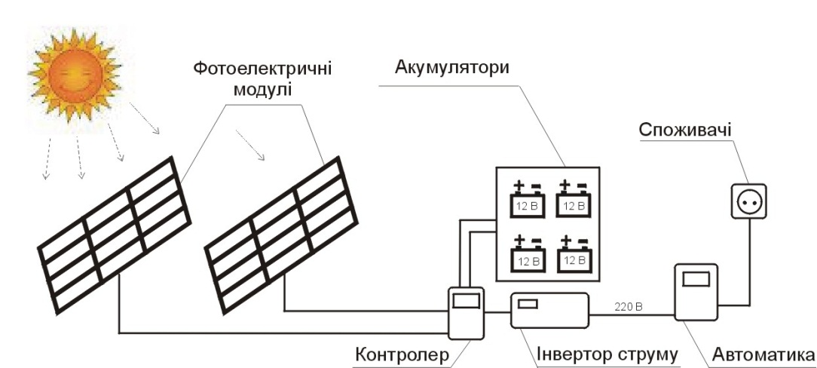
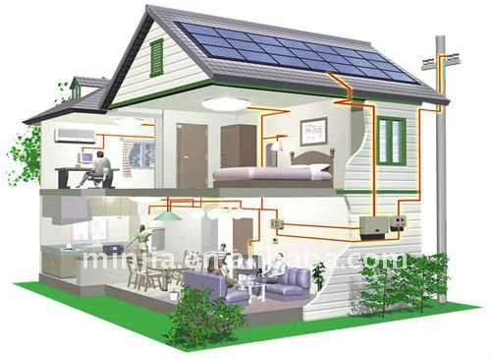

Features:
- Producer: Many companies in Ukraine (see Annex - VI)
- Capacity: Many options available
- Input: sunlight, photovoltaic solar panel
- Output: electricity
- Ensured energy supply year round as long as the day is sunny
- Payback period: 7-10 years

Advantages:
- It is mechanically very simple, no moving parts and no need of maintenance, except for periodic cleaning of the surface of solar panels.
- Produced electricity can be used instantly or can be stored in batteries for later use;
- Generation of electricity is completely silent
- Produces no carbon dioxide and other toxic fumes.
- It is very valuable in remote areas where houses are located away from power grid or where laying power line is unprofitable. It stands as alternative to diesel generator, especially when diesel is costly
Risks and disadvantages:
- Long payback period
- Not sustainable electricity generation (no electricity supply when there is no sunlight). For getting sustainable electricity generation better to use solar photovoltaic system in hybrid complex, for example: with wind, biomass, hydro electricity generation system.

Solar energy for heating (Solar Collector)
Description: Instead of heating water by gas or electricity (produced by regular or renewable sources), the sunlight/heat can be directly used to heat water. In this system, solar energy is converted to heat through solar collector. Some of the efficient systems can even collect solar power even during cloudy days. Solar heating system is the most accessible and effective in Ukraine. Its use can reduce twice fossil fuel consumption to get the same amount of energy.
Photo and simple scheme of solar collector and heat energy generating
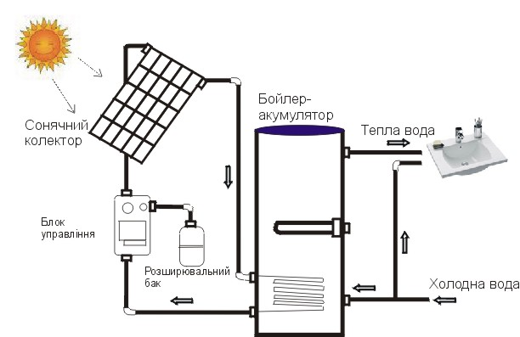

Solar collector - a device for collecting solar radiation energy in the visible and infrared spectrum. Coolant in these devices is mainly water that circulates through valves in the system. For comfort and efficiency of the collection, storage and use of solar energy for hot water supply used equipment drive (tank battery)

CBA-I project - Kaharlyk, Odeska oblast – combine solar heating and electro heating in kindergarten
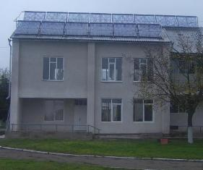

Features:
- Producer: Many companies in Ukraine (see Annex - VI)
- Capacity: Many options available
- Input: sunlight, solar accumulator panel
- Output: hot water supply
- Ensured energy supply year round as long as the day is sunny
- Payback period: 2-4 years
Advantages:
- Clean and cheap energy source
- Convenient
Risks and disadvantages:
- Efficient in spring and autumn, low energy supply in winter and surplus in summer
- For getting sustainable power generation, solar heating system should be used in hybrid form. For example: with natural gas, heat pump, biomass, air recuperation system etc.
- Additional cost needed on pump and running cost of the pump

2. Wind Energy
Description: Wind carries enormous amount of energy. With help of turbine wind energy is converted into electricity. Wind turbine is quite simple. It consists of a propeller with blades. With the blades wind-wheel is rotated by wind force passing through the gear torque on the shaft of the electricity generator. Thus, there is a conversion of mechanical energy into electrical energy. Generated electricity is stored in inverters and battery and is used smoothly. There are vertical and horizontal wind turbines. The one with horizontal axis and three blades cover 95% of all installed wind turbines over the world
This device is of two kinds – one that works well in low wind speed and produce relatively smaller amount of electricity and the other works well in high speed wind and produce more amount of electricity. This second type is bigger, heavier and costlier.

Simple scheme of wind electricity generating
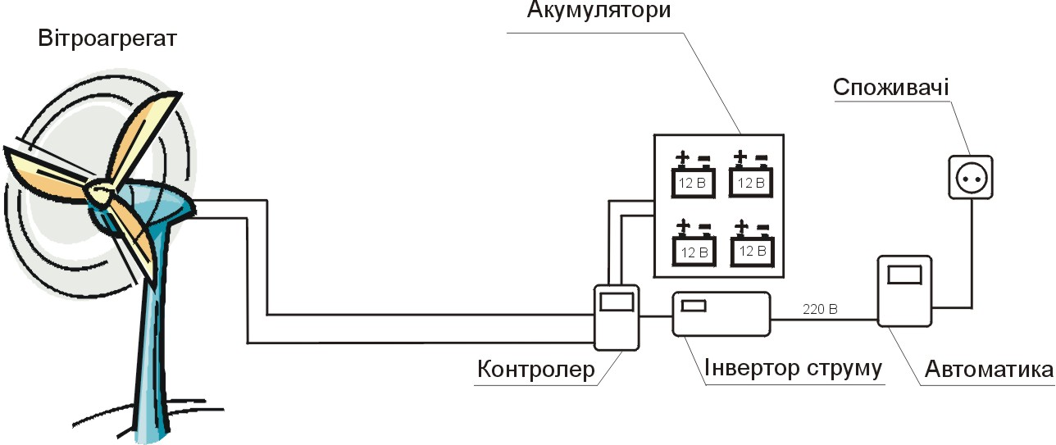

Features:
- Producer: Many companies in Ukraine (see Annex - VI)
- Capacity: Many options available
- Input: wind flow
- Output: electricity
- Ensured energy supply year round but depends on wind flow
- Payback period: 7-10 years
Advantages:
- Clean renewable energy
- Independent of electricity grid
- Can be used for pumping water in water supply system without frequency converter
- Can be used in conjunction with power from other energy sources
- Substantially save costs, while at the same time increase the stability of supply
Risks and disadvantages:
- Long payback period
- Not sustainable electricity generation (no wind, no power generation). For getting sustainable generation, hybrid complex should be used. For example: with solar, biomass, hydro electricity generation system.

Hybrid electricity generating complex based on solar and wind energy

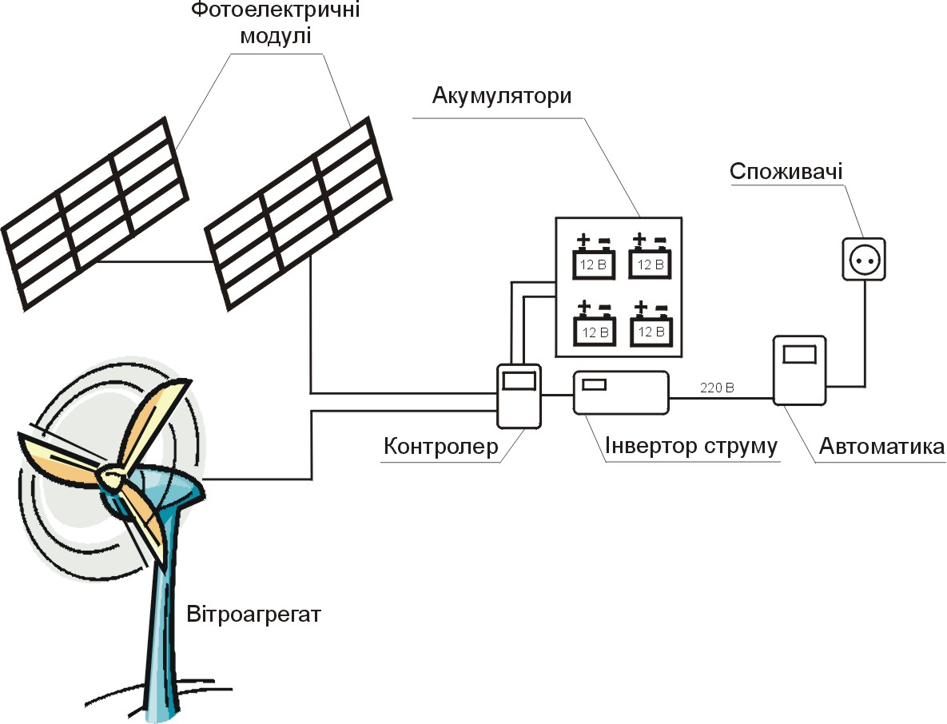

3. Biomass Energy
Description: Ukraine has quite a big potential of biomass available for energy production. It can satisfy about 13% of the Ukraine’s energy demand. The main components of the potential are:
- Agricultural residues: straw of grain crops, straw of rape, residues of corn crop (stalks, leaves, ears), residues of sunflower crop (stalks, husks, heads)
- Wood and waste of wood industry (dust, leaves etc.)
- Energy crops (poplar, miscanthus, acacia, alder, willow, corn, rapeseed etc.)
- Farm manure, landfill, sewage etc., to produce biogas (methane)
Bio-mass energy can be used for producing electricity or heat or both. As a result they can be used for several purpose in our day to day life e.g. heating, lighting, cooking, running machines/transportation engines etc..
a. Biogas
When organic material decomposes under anaerobic (lack of oxygen) conditions, it produces biogas which is a mixture of methane (CH4) and carbon dioxide (CO2) with small quantities of hydrogen, nitrogen, carbon monoxide and other compounds. Biogas can be used as a fuel source for cooking, heating, producing light or even fueling a generator. A BioGas digester is a device used to produce and capture this biogas. Organic materials of most forms (e.g. manure of animals and birds, kitchen scraps and gardening waste etc.) available in rural areas serve as main input. Of course different form of bio-input generates different amount of methane gas. Therefore, it will be wise to choose those inputs which generate higher amount of gas. In general, 2 cows or 10 pigs give enough manure to fuel a family daily cooking.

Simple scheme of biogas station
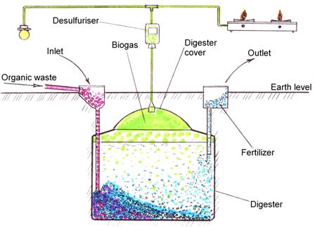
Features:
- Producer: Many companies in Ukraine (see Annex - VI)
- Capacity: Many options available
- Input: biomass
- Output: electricity and heat
- Ensured energy supply year round
- Payback period: 7-10 years
Advantages:
- Produces clean energy for household use.
- Cooking on biogas is quicker, easier, and more efficient than cooking on wood or charcoal
- Doesn’t need special equipment for cooking and heating
- Produces excellent nutrient-rich fertilizers for use on farms and gardens.
- Helps in the fight against global warming by allowing us to burn methane (which is harmful for the atmosphere)
- By utilizing a limitless supply of manure input, there will be no further necessity for costly resources such as propane, coal, or firewood and thus will allow for economical savings while supporting the regrowth of trees
Risk and disadvantages:
- Depends on waste suppliers, who are beneficiary CO-members. If they do not cooperate then the plant will fail
- Need heating for fermentation process in winter or special technical arrangement to maintain the temperature of the digester during winter
b. Solid Fuel Boiler
Description: solid fuel boiler is a device that can run on peat, coal, firewood, coke, lignite, waste paper, straw, pellets and other wood waste. Главные преимущества этого котельного оборудования в том, что оно полностью автономно и может успешно применяться в домах, где не проведено электричество и газ. The main advantage of the boiler is that it is completely autonomous and can be used successfully in homes where there is no place for electricity and gas. Твердотопливные котлы имеют достаточно высокий уровень КПД (до 85%), поэтому используются для полноценного обогрева помещений площадью до 200 м?. Modern solid fuel boiler has a high level of efficiency (85%), and therefore used for high-grade heating area of ​​200 m². ItОднако целесообразно использовать твердотопливные котлы в качестве дополнительного отопительного оборудования.Твердотопливные котлы довольно просты в использовании. is pretty simple to use andОн не требуют разработки специальных проектов и согласования с соответствующими инстанциями. does not require development of special project and coordination with the relevant authorities. Однако особое внимание следует уделить монтажу дымохода. However, special attention should be given to installation of the chimney. В противном случае не будут удаляться продукты сгорания.
Pyrolysis Boilers
Description: They are heating equipment, which functions on the technology of the combustion of pyrolysis (destructive distillation). Solid fuel boiler with combustion pyrolysis gas-generator is called Pyrolysis Boiler. It gasifies raw material (e.g. fuel wood) during pyrolysis (decomposition of complex organic compounds into simpler ones at high temperature) that produces "water gas" which burns to produce heat energy.
Simple scheme of pyrolysis boiler
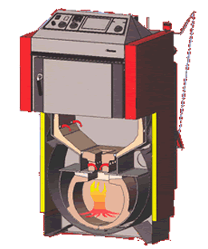
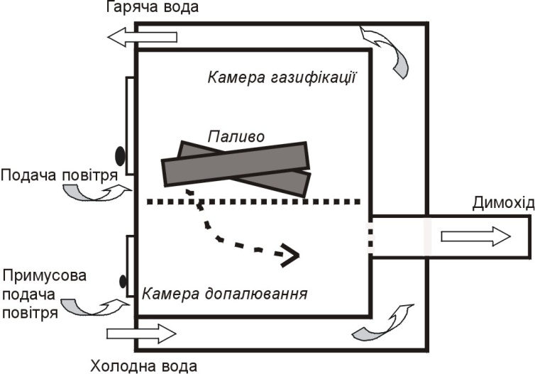

Features:
- Manufacturers/suppliers: in almost all regions of Ukraine(Appendix- VI);
- Capacity: from industrial to residential use;
- Input: biomass (wood and wood waste, agricultural wastes and other biomass);
- Output: heating and hot water supply;
- Ensured energy supply year round;
- Payback: 1,5-4 years

Advantages:
- Firewood might not be fully dry (it can work with up to 50% humid firewood)
- Does not require highly clean fuel wood (dirt, sand, stone attached wood can be used);
- Does not require oxygen (air pump) for burning
- It runs for 6-8 hours with one load of firewood irrespective of the size of the boiler. Of course, bigger the boiler bigger will be the ‘one load’ and bigger will be energy output
- It does not require intensive cleaning as it does not produce ashes
Risks and disadvantages: None or non-significant.

- Bio-Fuel

Bio-fuel includes mainly two products – bio-ethanol and bio-diesel.
Bio-ethanol is the most common form. It is produced from two sources using specific chemical transformation process:
- Fermenting sugar/starch containing mass (sugarcane, corn, sugar beet, potato etc.) and distilling to filter ethanol;
- Passing biomass wastes (e.g. agricultural residues, wood/wood wastes etc.) that are rich in cellulose through pre-treatment, hydrolysis and fermentation stages to receive bio-ethanol fuel.

Technology for extraction of bio-fuel exists in large, medium and small form for the producers to choose from. In rural areas, the community members could choose the small ones.

Features:
- Producer: Many companies in Ukraine (see Annex - VI)
- Capacity: Many options available
- Input: biomass that contains sugar/starch or cellulose
- Output: electricity and heat, fuel for transport
- Ensured energy supply year round
- Payback period: 1.5-3 years

Advantages:
- Easy to find raw material (biomass) for producing bioethanol
- Short payback period
- Local energy source
- Renewable source of energy

Risk and disadvantages:
- Bioethanol is alcohol. Production of alcohol is regulated by government and need special license (except own production and consumption).
- Some toxic reagent and waste of production require special utilization

Bio-diesel production is based on trans-esterification of vegetable oils and fats (extracted from rapeseed, sunflower etc.) through addition of methanol (or other alcohols) and a catalyst. Through various steps of processing bio-diesel is produced. This is mixed with regular fossil-diesel for running machines.

Technology for extraction of bio-fuel exists in large, medium and small form for the producers to choose from. In rural areas, the community members could choose the small ones.
Features:
- Producer: Many companies in Ukraine (see Annex - VI)
- Capacity: Many options available
- Input: agricultural products and wastes
- Output: electricity and heat, fuel for transport
- Ensured energy supply year round
- Payback period: 3-5 years
- Payback period: 1.5-4 years
Advantages:
- Easy to find raw material (biomass) for producing biodiesel
- Short payback period (if raw material is cheap)
- Local energy source
- Renewable source of energy

Risks and disadvantages:
- Expensive reagents for production
- Payback period significant depended from raw material price

4. Hydro Power
Description: Hydroelectric power system is a device that turns potential energy of water into energy of motion and then uses this energy to produce electricity. A hydroelectric facility requires a dependable flow of water and a reasonable height of fall of water, called the head. In a typical installation, water is fed from a reservoir through a channel or pipe into a turbine. The pressure of the flowing water on the turbine blades causes the shaft to rotate. The rotating shaft is connected to an electrical generator which converts the motion of the shaft into electrical energy. The amount of electricity produced is directly related to the head and speed of water flow. If the head or flow is increased the power output increases proportionally.
Often we witness large hydro-power plants, connected to national grid. However, technology (called micro-hydro power) has evolved that could produce enough electricity to serve one household or several households in the neighbourhood or an entire community. It is good where there is no national grid or cost of energy is high due remote location of the community.
Hydropower is well feasible in hilly regions where water falls exist or where river/rivulets flow fast from higher altitude to lower altitude or where there is possibility to use run-of-the-river (without making a dam) and direct pipes could be used to divert some of the flowing water, drop this down to a gradient, generate power through turbine and finally pour water back to the stream.
Fluid Hydro Electric
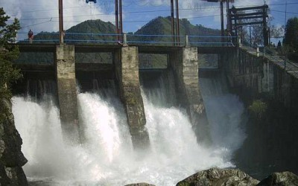 | 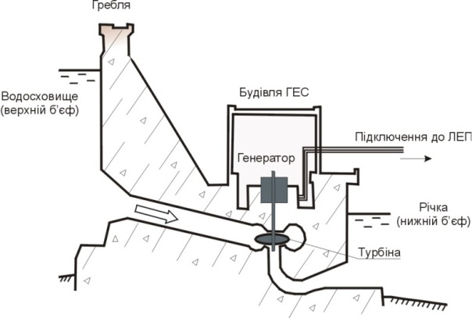

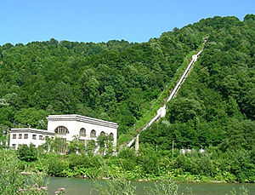
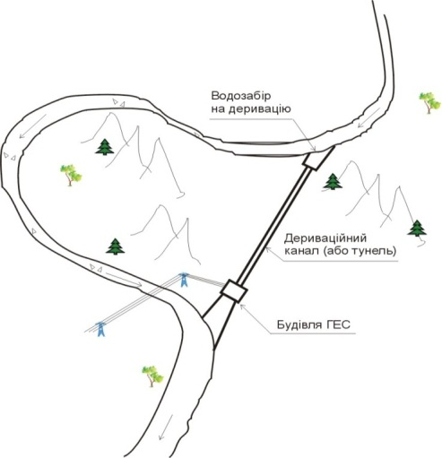
Derivational Hydro

Features:
- Producer: Many companies in Ukraine (see Annex - VI)
- Capacity: 5 kW – 100 kW
- Input: water
- Output: electricity
- Ensured energy supply year round
- Payback period: 7-10 years
Advantages:
- Clean renewable energy
- No CO₂ emission
- Local energy source
Risks and disadvantages:
- Long payback period
- Diverting of water may impact ecosystem of the river. Therefore, adequate care must be taken before selecting this technology. If necessary, local experts, NGOs and other stakeholders must be consulted
5. Geothermal
Description: Geothermal energy originates from the heat retained within the Earth since the original formation of the planet. Even cold ground contains heat. Below 3 meters, the ground is consistently 12.8 °C in moderate climates, and it may be extracted with a heat pump. Ground source heat pumps rely on an energy exchange between the air within the building being heated and the ground. During the summer when the ambient temperature of the building exceeds that of the ground, heat pumps are used to pump heat from the building into the transfer-medium (typically water with small amounts of ethanol or glycol) which is subsequently pumped through narrow pipes into the ground so that the heat can be dissipated in the earth. When the ambient temperature falls below the ground temperature the process works in reverse. Heat pumps extract heat from the ground and use it to heat the building.
There several types of heat pumps: geothermal heat pump (use geothermal energy), air heat pump (use air energy), and ones that use energy of water and ground for heating and/or conditioning.
Heat pump
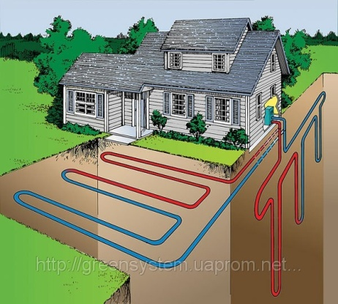 | 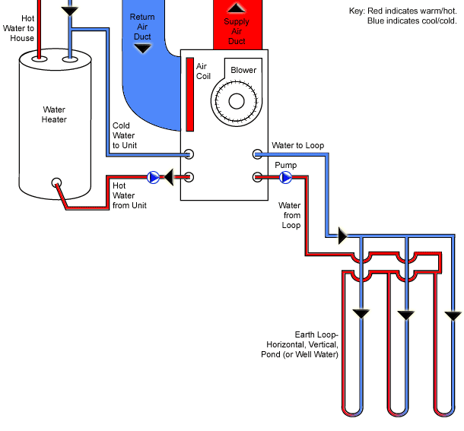

Scheme at http://www.gscgeo.com/GeothermalHeating.asp gives how the geothermal system works
Features:
- Producer: Many companies in Ukraine (see Annex - VI)
- Capacity: many options available
- Input: geothermal energy, air energy, energy of water and ground
- Output: heat and/or condition
- Ensured energy supply year round
- Payback period: 5-7 years
Advantages:
- Clean renewable energy
- No CO₂ emission
- Local energy source
- Maintains stable room temperature during summer and winter
- Can be used in form of hybrid complex with other renewable energy sources
Risks and disadvantages
- Long payback period
- If install vertical or horizontal geothermal heat pump need significant earthwork
Annex – V
Categories of Energy By Source and Technology
Technology | Energy Product | Status in Ukraine
Biomass
Combustion (CHP) | Heat /Electricity | Used for cooking and heating in residential and commercial sector. Used for heat and steam production by industry and district heating. Electricity generation (CHP) is insignificant. More than 1000 wood fired boilers operate in forestry and wood processing industry.
Gasification: power/fuel production | Electricity, heat  (CHP)/ Hydrocarbons,  methanol, hydrogen | Research and development
Hydrolysis and fermentation | Ethanol | Research and development; demonstration; some industrial production
Pyrolysis/production of liquid  and solid fuels | Bio-oils / charcoal | R&D, some industrial production
Extraction and digestion | Biodiesel / biogas | R&D; several pilot projects; some operating large-scale CHP biogas plant
Wind
Wind Turbines | Electricity | 70 MW installed power capacity
Wind mills and water pumping | Movement, power | Used in agriculture
Hydro
Hydro power stations | Electricity | Large-scale capacity: 4,600 MW; small scale: less than 100 MW
Geothermal
Geothermal power/heat stations | Heat, steam, electricity | 13 MW installed thermal capacity
Solar
Photovoltaic solar energy  conversion | Electricity | Manufacturing PV panels and systems. 230 MW installed power capacity of middle and big solar farm
Concentrating solar power | Electricity | n.a.
Solar heating and cooling ] | Heat, steam, cold | Manufacturing solar collectors for domestic use. Also exists for some industrial use.
Low-temperature solar energy use | Heat | Used for water and space heating, drying, cooking.

Annex – VI
Contact Information of Service Providers
Company | Tel # | website | Area of Service
Autonomous Republic of Crimea
Solar Company | (0692) 54-1852 | www.solarcompany.prom.ua | Solar heating | Solar electricity | Wind
Afros | (066) 863-4494 | www.afros.com.ua | Solar heating | Solar electricity | Wind |  | Heat pump
Alyans SV | (0652) 71 -4141 | www.allsv.com.ua | Solar heating | Solar electricity |  |  | Heat pump
Krym-Solar-Servis | (0692)92-6880 | www.solar.crimea.ua | Solar heating | Solar electricity
Vodniy Mir | (0652) 71-1266 | www.citadelplus.com | Solar heating | Condensing boiler | Biomass boiler |  |  |  | Electro-accumulative heating
Cherkasy Oblast
SunWind | (063) 605-4455 | www.sun-wind.com.ua | Solar heating | Biomass boiler | Win
CT Kavitus | (050)656-2392 | www.kavitus.com |  |  |  |  |  |  | Biodiesel
Cetus | (0472) 38-2904 | www.cetus.org.ua | Solar heating | Solar electricity | Wind |  | Heat pump |  | Biomass boiler
Chernihiv Oblast
BVM trading | ( 067)402-6644 | www.eurofuel.info |  |  |  |  |  |  | Biomass boiler
Luxor BK | (0462) 67-8680 | www.luxorbk.com.ua |  |  |  |  |  |  | Biomass boiler
Mogilev | (0462)97-4913 | mogilev.uaprom.net |  |  | Wind
Chernivtsi Oblast
Energysaving Systems | (0372)57-6164 | www.npower.com.ua | Solar heating | Solar electricity | Wind |  | Heat pump
Dnipropetrovsk Oblast
Ecopellets | (067)590-9449 | eco-pellets.com.ua | Solar heating |  |  |  |  |  | Biomass boiler
Alter Energy | (0562)31-4135 | alter-energy.com.ua | Solar heating | Solar electricity | Wind |  | Heat pump
MyFort | (056) 788-6780 | www.myfort.com.ua | Solar heating | Solar electricity | Wind |  | Street lighting
Alista | (056)732-2534 | www.alista.com.ua | Solar heating | Solar electricity | Wind |  | Heat pump |  | Biomass boiler |  | Street lighting
Vista Dnepr | (0562) 32-3822 | vistapellets.com.ua | Biomass boiler
Dnepr-Desna | (0562)35-08-44 | dnepr-desna.dp.ua | Biodiesel | Biogas |  |  | Biomass boiler
SV Metel | (056)791-1903 | natural-energy.com.ua | Solar heating | Solar electricity | Wind
FEV | (056)377-9778 | www.fev.com.ua | Solar heating |  | Wind
Eco Vision | (056) 377-7757 | www.ecovision.dp.ua | Solar heating | Heat pump
Donetsk Oblast
PPM – Technologie Gruppe | (067)625-5139 | ukrgasbiodiesel.com | Biodiesel
Grand Energo | (062)213-0121 | www.energo.dn.ua | Solar heating | Solar electricity | Wind |  | Street lighting
Dontechprom | (062)335-1584 | www.dontechprom.ua | Street lighting | Solar electricity | Wind
Kaylas | (0629) 49-1946 | www.kaylas.com.ua | Solar heating | Solar electricity | Wind
Special Technologies | (062) 647-7017 | www.spectech.dn.ua | Biodiesel
Technosoyuz | (062)306-2059 | technosoyuz.com.ua | Biodiesel
Ivano-Frankivsk Oblast
Frankeco | (0342) 73-8228 | www.frankeko.com.ua | Solar heating | Biomass boiler
Marilans | (0342)78-5500 | www.marilans.com.ua | Solar heating | Solar electricity | Wind |  | Biomass boiler |  | Electro-accumulative heating
Protek | (0342)77 35 39 | www.protek.if.ua | Solar heating | Solar electricity |  |  | Heat pump
Kharkiv Oblast
ComCom Group | (057)760-1994 | www.encom.com.ua | Solar heating | Solar electricity | Wind |  | Heat pump |  | Biogas |  | Biofuel
MNC Group | (057)752-3074 | www.mnc.in.ua | Biogas | Cogeneration
PENECO | (057)717-9713 | www.peneco.net | Biogas
EVS | (057) 719-3616 | www.evs.com.ua | Solar heating | Solar electricity | Wind |  | Heat pump
Solotoe Sechenie | (057) 731-8217 | www.gsukr.com | Solar heating | Solar electricity | Wind |  | Heat pump |  | Condensing boiler
Soldat | (057)719-4749 | www.soldat.kh.ua |  | Heat pump
Turboatom | (057) 349-2062 | turboatom.com.ua | Micro hydro
Alternative Energy | (057)731-3404 | alt-energy.com.ua | Solar heating | Solar electricity | Wind |  | Heat pump
Kherson Oblast
Sun Dream | (095) 042-8519 | sundream.com.ua | Solar heating | Solar electricity |  |  |  |  | Street lighting
Artis | (o552) 42-4393 | www.artis.ks.ua | Solar heating | Solar electricity |  |  | Heat pump
Neksfort | (050) 247-2036 | www.neksfort.com | Solar heating
Energia Svobody | (099) 421-5430 | www.freenergy.ks.ua | Solar heating | Solar electricity |  |  | Street lighting
Khmelnytskyi Oblast
Soncegraj | (0382)70-6З27 | soncegraj.com.ua | Solar heating
EkoAlt | (0382) 79-7937 | www.ekoalt.km.ua | Biomass boiler |  | Wind |  | Heat pump
Kiev Oblast
BNG | (067) 501- 0835 | www.bng.com.ua | Biogas
Bosch Buderus Thermotechnik Ukraine | (044) 390-71 93 | www.buderus.ua | Solar Heating | Heat Pump
CINK Hydro-Energy | (044)353-4727 | cink-hydro-energy.com | Small Hydro
CMP Europe BV | (050)387-3112 | www.pellets.org.ua | Biomass boiler
Elite House | (044) 222-9581 | www.e-h.com.ua | Solar heating | Solar electricity | Wind
Geoterm Ltd. | (044) 223-3442 | www.geoterm.com.ua | Heat pump
SETS, TM | (067)631 - 7124 | www.sets.com.ua |  |  |  |  |  |  | Biomass boiler
Viadrus | (044) 455-7898 | www.viadrus.com.ua |  |  |  |  |  |  | Biomass boiler
Intel Center | (067) 841-5671 | intelcenter.com.ua | Solar heating | Solar electricity | Wind |  | Heat pump |  | Biomass boiler  Small hydro |  | Cogeneration
Adept Amasa | (044) 3602798 | adeptamasa.com | Solar heating | Heat pump |  |  | Biomass boiler |  | Electro-accumulative heating
Admiral | (044)229-8228 | www.admirall.com.ua |  | Solar electricity | Wind |  |  |  | Street lighting
Aquadom | (044) 536-1351 | aquadom.com.ua | Solar heating |  |  |  | Heat pump |  | Condensing boiler
Alten System | (044) 227-5679 | www.altens.com.ua | Heat pump
Andey Energy | (044) 362-7994 | solarshop.com.ua | Solar heating | Solar electricity
Aston Engineering | (044) 353 0509 | www.astoneng.com.ua | Solar heating | Solar electricity | Wind |  | Heat pump
Winder | (044) 332-2660 | www.winder.ua | Wind
Atmosystems | (044) 599-6797 | atmosystems.com.ua | Heat pump
Atmosfera | (044)383-0084 | www.atmosfera.ua | Solar heating | Solar electricity | Wind |  | Heat pump |  | Biodiesel
SEC Biomass | (044) 456-9462 | www.biomass.kiev.ua | Straw boiler | Biomass boiler | Biogas
VDE | (044) 221-1188 | www.vde.com.ua | Heat pump
Geko | (044) 507-1606 | www.geko.kiev.ua | Solar heating | Heat pump
TEKOM | (067) 443-5734 | www.tekom.com.ua | Cogeneration
GEOTERM | (044) 223-3442 | www.geoterm.com.ua | Solar heating | Heat pump
GRAVICAPPA | (044) 379-3406 | gravicappa.com.ua | Solar heating | Solar electricity | Wind |  | Heat pump
Grand Overon | (044) 229-6495 | grand-overon.com.ua | Solar heating | Solar electricity | Wind
Gressa group | (044)401-1188 | www.ggc.com.ua |  | Solar electricity | Wind
DomArtTeplo | (044) 564-4492 | domartteplo.com.ua | Solar heating | Solar electricity | Wind |  | Heat pump
Eurodiesel | (044) 594-0655 | eurodiesel.com.ua | Cogeneration | Combined Heat, Power and Cold Generation
Evroclima | (044) 501-7400 | www.evroclima.com | Heat pump
Instalyator | (044) 592-8163 | www.install.in.ua | Condensing boiler |  |  |  |  |  | Biomass boiler
Kvazar | (044) 205-3400 | www.kvazar.com | Street lighting | Solar electricity
WindElectric | (044) 467-7788 | www.windelectric.ua | Street lighting | Solar electricity | Wind
Leacond | (044) 238-6121 | www.leacond.com.ua | Heat pump
NoviTerm | (044) 229-1779 | www.noviterm.com.ua | Solar heating |  |  | Heat pump
Nominal-T | (044) 229-2591 | www.nominal-t.com | Solar heating | Solar electricity | Wind |  | Heat pump
Prolin | (044) 244-7575 | www.prolin.com.ua | Solar heating | Solar electricity |  |  | Heat pump
Rentechno | (044) 332-81 90 | rentechno.com.ua | Solar heating | Solar electricity | Wind |  | Heat pump |  | Electroaccumulative heating
Teplonasos | (044) 229-5569 | www.teplonasos.ua | Heat pump
Teplosoyuz Ukraine | (044) 502-59 71 | www.teplosoyuz.com | Cogeneration | Biogas
Teplostar | (044) 227-1500 | www.teplostar.kiev.ua |  |  |  |  |  |  | Electroaccumulative heating
Viessmann | (044) 461-9841 | www.viessmann.ua | Biomass boiler | Condensing boiler
CET | (044)462-7304, | www.cet.kiev.ua | Solar heating | Heat pump
Kirovohrad Oblast
Texnoplus Kirovograd | (0522) 27-7625 | texnoplus.com.ua | Heat pump
Luhansk Oblast
UNITES | (0642) 52-6428 | www.unites.com.ua | Solar heating | Solar electricity | Wind |  | Biogas |  | Biodiesel |  | Street lighting
Lviv Oblast
Aurora Eco Energy | (032) 224-2078 | ekoenergy.com.ua | Solar heating | Solar electricity | Wind |  | Heat pump |  | Micro hydro
RomBudTrade | (032) 243-15 48 | www.teplo.lviv.ua | Heat pump
Techno-As | (032) 245-0068 | techno-as.com.ua | Solar heating | Solar electricity | Wind |  | Heat pump |  | Electroaccumulative heating
EkoKotel | (03254) 23999 | www.ekokotel.com.ua | Biomass boiler
Smart Systemy | (0322)92-2592 | www.asupro.com | Solar heating | Solar electricity | Wind |  | Heat Pump |  |  |  | Street lighting
Mykolaiv Oblast
MP Mriya | (0512)722160 | N/A | Solar heating | Solar electricity | Wind
Odessa Oblast
Green Energy | (048) 737-6026 | green-energy.org.ua | Solar heating | Solar electricity | Wind |  | Heat pump |  | Street lighting |  | Small hydro
DP Verano | (067)484-4124 | www.dpverano.com |  |  |  |  |  |  | Wind
Sojuskompleks | (048)788-3905 | www.sojuz.com.ua | Solar heating | Heat pump | Wind
Star Energy | (048) 784-6291 | star-energy.com.ua | Solar heating | Solar electricity | Wind |  | Heat pump
Teplo Trade | (048) 784-6154 | teplotrade.com.ua |  | Biomass boiler | Condensing boiler |  |  |  | Electroaccumulative heating
Unikon | (048) 760-1146 | www.unikon.at.ua | Solar heating | Solar electricity | Wind |  | Heat pump |  | Electroaccumulative heating
Ecotek3000 | (048) 703-5465 | www.ecotek3000.com | Solar heating | Solar electricity | Wind |  | Heat pump
Poltava Oblast
Ukrbudmash | (0532) 66-8566 | ukrbudmash.com.ua | Biodiesel
EA | (0532)-69-2636 | www.advice-ua.com | Cogeneration | Biogas |  |  | Biomass boiler
Rivne Oblast
IVT | (0362) 62-3347 | www.ivt.rv.ua | Heat pump
Sumy Oblast
Castrade-Esco | (0542) 65-9105 | castradeesco.com.ua | Cogeneration
Ternopil Oblast
Zennoff | (0352)40-4031 | www.zenoff.ucoz.ru | Solar heating | Solar electricity | Wind |  | Small hydro
Siriusone | (0352) 52-3495 | www.siriusone.net | Solar heating | Solar electricity | Wind |  | Heat pump |  | Street lighting
Vinnytsia Oblast
Alternative Energy | (0432)53-5535 | www.biogas.vn.ua | Biogas
Partner VS | (067)274-9017 | partvs.vinnitsa.com |  | Solar electricity
Volyn Oblast
Solarpol | (067)361-6517 | www.solarpol.com.pl | Solar heating | Solar electricity |  |  | Heat pump |  | Biomass boiler
Zakarpattia Oblast
SOLAR Karpathy | (0312) 44-9548 | solarkarpathy.com.ua | Solar heating | Solar electricity | Wind |  | Heat pump
Zaporizhia Oblast
Motor Sich | (061) 720-4814 | www.motorsich.com | Biomass boiler |  | Wind
SintSolar | (061)213-6115 | www.sintsolar.com.ua | Solar heating
Plastec | (061) 700-6061 | plastec.uaprom.net | Solar heating | Solar electricity | Wind
Zhytomyr Oblast
Kriger | (0412) 48-1532 | www.kriger.com.ua | Biomass boiler

Annex – VII
Participation Form for Rayon

Rayon: ……………………. Region: ………………….

Contact Person: …………. Tel # : …………… E-mail: ………

- Describe potential renewable energy sources in the rayon (as far as possible, based on scientific studies/government decision etc.) e.g. wind energy, solar energy, bio-energy etc.
(Weightage: More than 3 resources = high; 2-3 resources = medium, 1 resource = low). Max. Score – 15

- Provide assessment of the rayon in terms of gas supply to the communities (based on the information/report available at the gas supply office, rayon state administration office or any other reliable source in the rayon). Considering only those village/city councils with less than 10,000 population indicate % of settlements/micro-rayons (of these councils), select one of the following possibilities. (Max Score – 15).
  - All are connected; b) More than 90% are connected; c) 80-90% are connected; d) 60-80% are connected; e) Less than 60% are connected

- Provide assessment of the rural communal infrastructures facing energy inefficiency problem (based on the information/report available rayon state administration office or any other reliable source in the rayon, select one of the options below). (Max. Score – 15).
  - More than 90% are facing serious energy inefficiency problem
  - 70-90% are facing serious energy inefficiency problem
  - 40 – 70% are facing serious energy inefficiency problem
  - 10 – 40% are facing serious energy inefficiency problem
  - Less than 10% are facing serious energy inefficiency problem

- Provide assessment of rayon budget cost (including transfers from other budgets) allocated for payments for energy resources (electricity, natural gas, heat, etc.; excluding gasoline for transport) in rural territories of the rayon. (Max. Score – 10).
a) ………………… UAH
b) …………………... % (of the total energy budget of the rayon)
- Availability of special programme & budget to exploit renewable energy opportunities for the rural areas of the rayon (base your response on the decision of the rayon council or approved programme being implemented in the rayon. Please select one of the followings). (Max. Score – 15).
  - The rayon has approved programme and budget with clear definition for rural areas
  - The rayon has approved programme and budget without clear direction for rural areas
  - Programme has been approved but budget has not been allocated
  - Approved strategy exists and the programme preparation is underway
  - Broad strategy exists but relevant programme for rural areas is not yet developed

- Level of technical capacity to work on renewable energy sector and/or the capacity it can mobilise from existing non-government sector in the rayon (consider in terms of human resources/agency specialized in energy sector e.g. number of main experts/specialists, competent agencies in the locality etc.)
(Weightage: Adequate = high; Less than adequate = medium; inadequate = low). Full score – 10

- Make a self-assessment of overall performance of the rayon in implementing CBA methodology (Indicate excellent, medium, low etc. along with arguments, as necessary). Maximum Score - 10

- Describe commitment of the Rayon State Administration/Rayon Council to promote and support energy efficiency in rural area, including through renewable energy sources (Verify the level of commitment through existing energy strategy, energy plan, and budget allocated or reflected in the social-economic program).
Maximum Score - 15

Annex– VIII
CBA Methodology for Competent CO Development
- Selection Community
CBA Project selects a rayon for partnership based on competition among all rayons in an oblast. Similarly, 4 or more village/city councils (with less than 10,000 population) are selected from partner rayon based on competition.
A Ukrainian community located in a village council or city council will be eligible for participation in the ‘energy efficiency enhancement’ support of CBA Project if it is selected for participation on competition basis from among all the communities in the village/city council. The competition is based on such criteria of socio-economic hardship including energy supply, water supply, health service, environmental problems and poverty.
A partner village/city council calls its communities for to participate in the competition. Active members of the community submit their community profile with argument on their eligibility for getting selected. A community selection team consisting of officials from rayon and regional authorities and CBA-coordinator in the region review the proposals and make the selection.
Active members of a community should be in touch with the officials of village/city council to learn about possibility of participation of their community.
- Formation of Community Organisation (CO)
A community mobilisation team (CMT) led by the CBA/coordinator holds dialogue with the general members of the community and makes them understand about value and process of working together to solve problems of the community in partnership with local authorities, CBA Project and other sponsors.
In case 80% or more households of the community agree the idea, they will decide to form a community organisation. The CMT will provide detail information regarding type of organisation to be formed, formation of CO-executives and process of its registration. CO gives community members a legal platform for undertaking collective action.
In case there is already an organisation in the community (from the first phase of CBA or otherwise) and 80% or more households prefer to continue it for partnership then CMT may consider grafting the same. Grafting involves reviewing the statute, functions and previous track record and testing the capacity of the CO through participatory assessment and maturity test.
- Developing Capacity for Institutional Maturity
Before undertaking any micro-project in partnership with CBA Project, the CO must prove its capacity and maturity. For this purpose followings must occur:
- Training: The CO-executives and other active members should participate in the trainings organised by CBA Project. The trainings include such area as organizational management, financial management, participatory planning; legal registration of CO and so on;
- Enrollment: The CO should be enrolled with respective village/city council;
- Registration: The CO should be registered in legal form. Popular legal forms are Bodies of Self-Organisation of Population (BSP), Non-government Organisation (NGO), Cooperative (Co-op) and Association of Co-owners of Multi-storey Building (ACMB). The CO-members should understand strengths and weaknesses of each form before preparing statute and submitting request for registration. In case the CO –members are determined to undertake energy efficiency related micro-project, then they should choose one of the following options:
  - Whether they will keep the object in their ownership and be responsible for operation and maintenance; or
  - Whether they would like to see the object in the ownership of local/state authorities and be a partner of the owner in operation and maintenance.
In first case, they should choose a cooperative or ACMB forms while in second case they could choose NGO (non-profit) or BSP form.
CMT, local council and designated official (focal person) of the rayon authority will provide necessary assistance in getting the CO registered;
- Setting financial system: The CO must open a bank account in its name. Necessary decision regarding the choice of bank and signatories of the account will have to be made by CO-members. Also, it must establish necessary accounting and book keeping system to the level of satisfaction of the legislation of the country;
- Establishing system of transparent governance: The CO must establish a system of open decision-making (preferably based on consensus) and regular reporting to the stakeholders;
- Creation of special purpose fund: The CO should have special fund for special activities it will carry out. These funds will be separated in accounting system while all the income could be put in the same (and the only) account in the bank. They could be – organizational development fund (ODF) to meet management cost of the CO; community development fund (CDF) to meet the cost of implementing micro-projects; and operation and maintenance fund (OMF) to maintain the object created/rehabilitated by the CO;
- Networking with other organisations: The CO should join the local development forum (LDF) formed under the chair of rayon state administration with members including CBA partners at local level (village/city councils, COs) and others involved in the process (private businesses, NGOs, chamber of commerce, donors including CBA Project etc.). It may also network with similar COs for the purpose of raising collective voice or for expanding collective strength for to undertake bigger community projects;
- Initial practice in community development: The CO should carry out small initiative(s) on its own to practice the norms of working together and maintaining institutional quality of governance and accountability;
- Passing maturity test: The CO must pass the test of maturity conducted by the CMT. It should correct weaknesses found during the test.
- Participatory Planning
The CO should carry out a participatory planning in participation of its general members. During this event the members identify development problems facing the community. List of identified problems ought to be prioritized based on criteria of feasibility (technical, social, environmental, economic), do-ability (within capacity of the CO to implement and maintain), sustainability (ownership and operational responsibility of the CO) and so on. The CO should prepare a brief community development plan (CDP) out of the priorities set by the members.
In case the CO-members identify energy efficiency/alternative energy technology as a priority to undertake then this manual remains applicable for further steps to be followed.

Annex – XI
Micro-Project Idea

Name of CO: Village/City Council: Rayon: …………………….

Contact Person: …………. Tel # : ……………

- Information about Community Organization (CO)
  - CO formation date (date of first CO protocol) : …………
  - CO grafted date (if formed before June 2011): …………
  - Legal category (BSP, Cooperative, ACMB, NGO): ……….
  - Total households on the territory of the CO:
  - Total households represented on the CO: (a) Main member - (b) Associated Member -
  - Status of financial management in UAH.
SN | Type of Fund | Collected | Utilised | Balance
1 | Membership fee
2 | Micro-project contribution
3 | Operation and Maintenance fund
4 | Other income
 | Total UAH
Note: Item 2 and 3 may be related with the micro-project already implemented/being implemented
but not for the planned one
1.8 Level of institutional maturity of the CO (if available):
- Score of PAS (attach the score card) - ….%
- Score of maturity index (attach score card) - ….%
- Information on Community Development Plan
2.1 Total number and type of projects identified by CO:
- Project for social development:
  - xxxxx
  - xxxxx
- Projects for economic development
  - xxxxx
  - xxxxx
- Projects for environmental protection
  - xxxx
  - xxxx

2.2 Type and name of projects prioritised by CO in Development Plan
Name of project | Type of project  (Social, Economic, Environmental etc.) | Priority № of the project
 |  | 1
 |  | 2
 |  | 4
 |  | 3
 |  | 5

2.3 Date on which the priority was accepted by the general meeting of the CO: …………
- Information about the Proposed Micro-Project for Funding
3.1 Title of the Micro-Project:
3.2 Describe energy problem which is planned to solved by the proposed MP (example such as current energy system is costly, there is a need to reduce pollution caused by existing energy equipment, current energy supply capacity is inadequate etc.)
3.3 Describe what technology and equipment are being used currently to meet energy need (when installed, main technical features of equipment, brief explanation of used technology)
3.4 Technical design and cost estimate (mark one) is: (a) available, (b) in process of preparation, (c) planned
3.5 Estimated tentative total Cost (UAH) and proposed cost sharing arrangement:
S.N | Proposed Sponsors | Type and amount of contribution |  |  | Remarks
S.N | Proposed Sponsors | Cash | Kind* | Total | Remarks
1 | Community Organization
2 | Village/City Council
3 | Rayon Administration
4 | Oblast Administration
5 | CBA Project
6 | Private businesses
7 | Others
 | Total
* Contribution in kind should be converted in terms of money and written in the column “in kind contribution”.
3.6 Describe how the proposed MP will be implemented (consider kind of technology that will be employed, place of equipment installation, who will own it, who will maintain it etc.)
3.7 Expected duration of implementation : (a) starting date: xx/xx/xxxx; (b) completion date: xx/xx/xxxx
3.8 Expected beneficiaries: (i) HHs: ---- (ii) Population: ---- (a) Male: --- (b) Female:---- (c) Children: ……..
3.9 Expected benefit and impact from the project implementation (describe considering such ideas as reduction in CO₂ emission/pollution; lower consumption of energy leading to saving in energy bill; economic attractiveness of the project and cost return; addition of energy to national system; improvement in health, new knowledge/skill gained in innovative technology/renewable energy etc.)

3.10 Date of approval of the micro-project idea by key stakeholders (local council, rayon authority): ………
3.11 Proposed arrangement for operation and maintenance of the project (Make preliminary assessment of operation and maintenance cost; provide preliminary estimation of CO contribution to Operation and Maintenance Fund)
…………………………….. Stamp ________
Name (CO-Chairperson)
Date: xx/xx/x
Response from rayon authority
- Experience of implementation similar technology (scale of similar MP implemented in the rayon)
- Disadvantages of proposed technology (if any) and how they will be mitigated
- Potential of replication of proposed technology (how many similar MP in the rayon likely to be implemented in future)
…………………………….. Stamp ________
Name:
Designation:
Date: xx/xx/x
Annex-X
Simple Proposal Format

To
The Regional Micro-Project Selection Committee
Energy Efficiency Support
CBA Project for ………….. Oblast, Ukraine

Subject: Recommendation for Inclusion of Proposals in Competition

Meeting of Local Development Forum dated ………… reviewed the development plans and micro-project ideas submitted by CBA/community organisations in the rayon and decided to recommend following proposals for regional level competition on energy efficiency. The rayon authorities and respective local councils hereby express their commitment to provide resources as marked under cost sharing.

SN | Village/City Council | Community Organisation | Title of Micro-Project | Key Tasks | Expected Cost UAH | Proposed Cost Sharing
 |  |  |  |  |  | CO | VC/CC | Rayon/  Oblast | CBA | Others
1 |  |  |  | Solar Power
 |  |  |  | Improved Boiler
 |  |  |  | Window insulation
 |  |  |  | ….
2

Copies of the micro-project ideas are also attached herewith.

Date : ………… -----------------------------------
Name ………….
Head of LDF, …… Rayon

Annex - XI

MP Idea Evaluation and Ranking

SN | Rayon | Name of the CO | 1. Nature of MP Idea |  | 2. Nature of Technology |  |  | 3. Energy Independence
SN | Rayon | Name of the CO | Energy Production | Saving & production | Energy efficient | Renewable | Mixed | Contributes | Consumes | Both
SN | Rayon | Name of the CO | 3 | 5 | 3 | 5 | 4 | 5 | 2 | 4
1 | 2 | 3 | 4 | 5 | 6 | 7 | 8 | 9 | 10 | 11
1
2
3
4
5
6

SN | Rayon | Name of the CO | 4. Level of Coverage |  |  | 5. Level of Expected Benefit |  |  | 6. User
SN | Rayon | Name of the CO | Comprehensive | Partial - Adequate | Partial - Inadequate | Pollution Decline | Energy Saved &Added | Others | Community | Public building | Both
SN | Rayon | Name of the CO | 4 | 5 | 2 | 2,3,4,5 | 2,3,4,5 | 1,2,3,4,5 | 4 | 3 | 5
1 | 2 | 3 | 12 | 13 | 14 | 15 | 16 | 17 | 18 | 19 | 20
1
2
3
4
5
6

SN | Rayon | Name of the CO | 7. Local Cost Sharing |  |  | 8. Quality & Performance of CO |  |  | 9. Expansion |  |  | Total Score  (Max 65) | Ranking
SN | Rayon | Name of the CO | up to 30% | 30-40% | >40% | PAS | Maturity Index | O & M for old CO | Many | Middle | Low | Total Score  (Max 65) | Ranking
SN | Rayon | Name of the CO | 3 | 3-4 | 5 | 0,2,3,4,5 | 0,2,3,4,5 | 0,2,3,4,5 | 5 | 4 | 2 | Total Score  (Max 65) | Ranking
1 | 2 | 3 | 21 | 22 | 23 | 24 | 25 | 26 | 27 | 28 | 29 | 30 | 31
1
2
3
4
5
6

Weightage for scoring mentioned under column number. Specifics are given below:
- Column 1: Numeration
- Column 2: Name of the rayon
- Column 3: Name of the CO

Indicator #1. Nature of MP Idea (select only one column from 4-5)
- Column 4: Select this column and put score if technology only energy producing. For more information look p.3.2 in this manual
- Column 5: Select this column and put score if technology is energy saving and energy producing.Look p.3.2 in this manual

Indicator #2. Nature of Technology (select only one column from 6-8)
- Column 6: Select this column and put score if technology is innovative energy efficient one. For more information look Annex III in this manual
- Column 7: Select this column and put score if technology is renewable energy one. For more information look Annex IV in this manual
- Column 8: Select this column and put score if technology is mixed renewable energy and innovative energy efficient one.

Indicator #3. Energy Independence (select only one column from 9-11)
- Column 9: Only for renewable energy project which doesn’t depend from any source that should be paid or this dependence is negligible.
- Column 10: Only for innovative energy efficient technology.
- Column 11: Select this column for renewable energy if operation costs (electricity, fuel) is significant or it is mixed renewable energy and/or innovative energy efficient technology.

Indicator #4. Level of Coverage (select only one column from 12-14)
- Column 12: If MP idea proposed complex approach of energy saving measure and installing innovative energy efficiency and/or renewable energy technology.
- Column 13: If energy saving is completed and only energy producing is proposed. So complex approach will be realised.
- Column 14: If energy saving is completed partly and energy producing is proposed. So complex approach will be not realised, MP will solve problem partly.

Indicator #5. Level of Expected Benefit (estimate each column from 15-17)
- Column 15: 5 for the highest decline – to – 1 for the lowest emission decline. Specifics are given below:
  - Give 5 score if one of them: solar, wind, hydro, heat pump
  - Give 4 score If one of them: pyrolysis boiler, biogas, biodiesel, bioethanol
  - Give 3 score if one of them: condensing boiler, electro-accumulative heating, cogeneration.
  - Give 2 score if one of them: modern solid biomass boiler
- Column 16: 5 for the highest energy saved and added – to – 1 for the lowest one. Estimate in the standard fuel.
- Column 17: 5 for the highest level of other estimated benefits (e.x. social and economic ones) – to – 1 for the lowest one. Specifics are given below:
  - Give 5 score if creates jobs, improve health, support local (rayon, oblast) equipment producer, rise a level of service quality, others
  - Give 4 score if only 4 from mentioned up criteria
  - Give 3 score if only 3 from mentioned up criteria
  - Give 2 score if only 2 from mentioned up criteria
  - Give 1 score if only 1 from mentioned up criteria

Indicator #6. User (select only one column from 18-20)
- Column 18: If community will earn energy benefit.
- Column 19: If building will earn energy benefit.
- Column 20: If both community and building will earn energy benefit.

Indicator #7. Local cost sharing (select only one column from 21-23)
- Column 21: If CO, budget, private sponsors and other donors share will be up 30%.
- Column 22: Score from 3 to 4 If CO, budget, private sponsors and other donors share will be 30%-40%. (e.x. 31% - 3.1 score, 36% - 3.6 score)
- Column 23: If CO, budget, private sponsors and other donors share will be more 40%.

Indicator #8. Quality & Performance of CO (estimate each column from 15-17)
- Column 24: 5 for the highest PAS – to – 1 for the lowest one. Specifics are given below:
  - Give 5 score for excellent/sustainable level of PAS
  - Give 4 score for satisfactory/good
  - Give 3 score for moderate
  - Give 2 score for week
  - Give 0 score for serious
- Column 25: 5 for the highest maturity index – to – 1 for the lowest one. Specifics are given below:
  - Give 5 score for excellent maturity level
  - Give 4 score for good
  - Give 3 score for satisfactory
  - Give 2 score for weak
  - Give 0 score for serious
- Column 26: 5 for the best O&E and – to – 1 for the worst one. Specifics are given below:
  - Give 5 score if signed MOU (or agreement) with object owner, has accumulated money in the O&M Fund and appointed responsible person for O&M.
  - Give 4 score if signed MOU (or agreement) with object owner, has accumulated money in the O&M Fund.
  - Give 3 score if has accumulated money in the O&M Fund and appointed responsible person for O&M.
  - Give 2 score if signed MOU (or agreement) with object owner.
  - Give 0 score if not signed MOU (or agreement) with object owner and has not cumulated money in the O&M Fund.

Indicator #9. Expansion (select only one column from 21-23). Refer to the response from rayon authority on the MP idea.
- Column 27: If possible to implement the similar project on the more than 10 objects in the rayon.
- Column 28: If possible to implement the similar project on the 4-10 objects in the rayon.
- Column 29: If possible to implement the similar project on the 3 and less objects in the rayon.

- Column 30: Total score from 1-9 indicators
- Column 31: Ranking according to the score. The more score the higher place (starting from #1)

Annex – XII
Description about Energy Efficiency Passport
Energy Efficiency Passport (EEP) provides a means of rating individual buildings – whether residential, commercial or public – on how efficient (or inefficient) they are in relation to the amount of energy needed to provide users with expected degrees of comfort and functionality. The degree of efficiency depends on many factors including: local climate; the design of the building; construction methods and materials; systems installed to provide heating, ventilation, air condition or hot sanitary water; and the appliances and equipment needed to support the functions of the building and its users.
Energy certification of buildings typically involves three main steps:
- Assessment of the energy performance of a building by a competent assessor using a reliable methodology;
- Issuance of a certificate rating the building’s energy performance which includes, in some cases, information on possible improvements likely to yield energy savings;
- Communication of this information to stakeholders through publication of the certificate.
EEP contains information about existing level of energy consumption and possible improvement in consumption if energy saving/efficiency measures are undertaken. Comparing EEP before and after undertaking of the measures reflect level of realization of potential improvement and net benefit achieved in terms of energy saving, money saving, reduced greenhouse effect and so on. Energy efficiency certification of buildings is widely used in EU. Some activities in this sphere occur in Ukraine as well. Legislation is being developed to this end. However, some regions are using European experience (i.e. already developed methodology) and implemented energy efficiency certification in their region.
Why is energy certification of buildings important?
Improving energy efficiency in buildings is one of the most cost-effective ways across all sectors to reduce energy consumption and hence greenhouse gas emissions. Energy certification increases awareness of energy consumption and enables consumers to compare buildings, thereby providing builders with an incentive to improve energy efficiency in buildings. Display Energy Certificates (DECs) show the actual energy usage of a building, the Operational Rating, and help the public see the energy efficiency of a building (example below).

Why is energy certification of buildings important for CBA?
- Raising public awareness about energy efficiency
- To measure the return of investment made by the Project for raising energy efficiency;
- To compare energy saving performance of different technologies
National Standard Guidelines was developed in Ukraine (in 2007) for the Development and Drafting of the Energy Passport for Buildings New Construction and Reconstruction. According to this standard, energy classification of buildings and Ukrainian energy passport was developed as given in Tables below. The classification gives understanding about the level of energy efficiency in the buildings.

Table - I: Scale of Energy Efficiency Rating (General)
Energy rating | Energy evaluation | Energy coefficient (kWh/m² per year)
А+ | Zero | up 15
А | Passive | 15 - 45
В | Very Low | 45 - 80
C | Low | 80 - 100
D | Medium (meet actual requirements) | 100 - 150
E | High | 150 - 250
F | Very High | above 250

Table - II: Scale of Energy Efficiency Rating by Type of Objects
Annual consumption, kW/m2 | A | B | C | D | E | F | G
Private household | to 50 | 51-90 | 91-150 | 151-230 | 231-330 | 331-450 | over 450
School | to 75 | 75-140 | 140-205 | 205-270 | 270-335 | 335-400 | over 400
Social-culture object | to 75 | 75-160 | 160-245 | 245-330 | 330-415 | 415-500 | over 500
Kindergarten | to 75 | 75-145 | 145-215 | 215-285 | 285-355 | 355-425 | over 425
Hospital | to 150 | 150-225 | 225-300 | 300-375 | 375-450 | 450-525 | over 525

Table - III: Sample of EEP for a Building (example of Zakarpatska oblast)
I. Building information
1. Name of facility |  |  |  |  |  |  |  |  |  |  |  |  | 2. Rayon
3. Address |  |  |  |  |  |  |  |  |  |  |  |  | 4. Settlement
5. Number of alone stay building (if more than one, each form will fill for every building
6. Main characteristic of building (fill separate for each building)
Block: |  |  |  |  |  | Year of construction: |  |  |  |  |  |  | Number of floor: |  |  |  |  |  |  | Property:
Total area,  m² |  |  |  |  |  | Heating area,  m² |  |  |  |  |  |  | Volume of building  m³ |  |  |  |  |  |  | Area of floor (footing)  m²
Total facade area  (without window)  m² |  |  |  |  |  | Total window area  m² |  |  |  |  |  |  | Design capacity |  |  |  |  |  |  | availability of catering department
7. Building envelope of the building
Walls | Brick |  |  |  |  |  | Concrete |  |  |  | Wood |  |  | _________ |  |  |  | Insulation  mm
Window glass | Single |  |  |  |  |  | Double |  |  |  | Triple |  |  | _________ |  |  |  | ____item
Glass pack | Single |  |  |  |  |  | Double |  |  |  | Triple |  |  | _________ |  |  |  | ____item
Window frame | Wood |  |  |  |  |  | Aluminum |  |  |  | Plastic |  |  | _________ |  |  |  | ____item
Roof | Tent |  |  |  |  |  | Flat |  |  |  | Wood floor |  |  | Concrete floor |  |  |  | Insulation  mm
Floor on the ground level | Under ground |  |  |  |  |  |  |  |  |  | Under not heat basement |  |  |  |  |  |  | Insulation  mm
8. Energy counting equipment
Heating |  |  |  |  | Electricity |  |  |  |  | Natural Gas |  |  |  |  |  | Cold Water |  |  |  |  | Hot Water
9. Usage building
Year round  Seasonally |  |  |  | Number of working day in year
 |  |  |  | Number of working day on week
 |  |  |  | Number of working day in day
10. Heating system: |  |  |  |  |  |  |  |  | Capacity, KW |  |  |  |  |  |  |  | Installation year _________
Energy supply: |  |  | Central heating |  |  |  |  |  | Natural gas |  |  |  | Electricity
 |  |  | Coal |  |  |  |  |  | Firewood |  |  |  | _________
Heating system: |  |  | Radiator |  |  |  |  |  | Convector
 |  |  | Electric |  |  |  |  |  | _________ |  |  |  | Other
Radiator: |  |  | Iron |  |  |  |  |  | Aluminum |  |  |  | Steel |  |  |  | Thermal screen
Layout of the heating system (pipes) |  |  | Metal |  |  |  |  |  | Metal-Plastic |  |  |  | Polypropylene |  |  |  | Insulation  mm
Thermostatic valves |  |  | None |  |  |  |  |  | Old |  |  |  | New
Valve before radiator |  |  | None |  |  |  |  |  | Old |  |  |  | New
Automatics |  |  | None |  |  |  |  |  | Old |  |  |  | New
Temperature regulation |  |  | Yes |  |  |  |  |  | No
11. Ventilation |  |  |  |  |  |  |  |  |  |  |  | Capacity________KW Installation year _________
System: |  | None |  |  |  |  |  | Old |  |  |  | New |  |  | Natural ventilation |  |  |  | Exhaust ventilation
Recuperation: |  | None |  |  |  |  |  | Exist |  |  |  | _________
12. Hot water supply
Energy supply: | Central hot water supply |  |  |  |  |  | Natural gas for hot water |  |  |  | Electricity for hot water |  |  | Other |  |  |  | Capacity  KW |  |  |  |  | Installation year _________

II. General energy carrier consumption during 2009-2011
Energy type | Amount |  |  | Expenses, thousand UAH
Energy type | 2009 | 2010 | 2011 | 2009 | 2010 | 2011
Heat (MWh)
Electricity (MWh)
Natural gas (thousand m³)
Coal (tonne)
Firewood (m³)
Liquefied gas propane-butane (tonne)
Hot water (MWh)
Other
Total

Water | Amount |  |  | Expenses
Cold water (m³)
Hot water (m³)

Responsible official, position, phone number sign Name

Head of facility, position, phone number sign Name
Date “___”_____________2012 Stamp
Annex – XIII
Micro-Project Proposal Form
- Information about Village/City Council
  - Name of Village/City Council:
  - Number of settlements/Micro-rayon:
  - Total population:
  - Name of Head of Village/City Council:
  - Contact Tel/e-mail:
  - Name of contact person (if different than 1.5):
  - Contact Telephone/e-mail:
- Information about Community Organization (CO)
  - Name of the territory (settlement/micro-rayon/multi-apartment building):
  - Name of CO:
  - CO formation date (date of first CO protocol) : xxxx
  - Date of enrolment with local council:
  - Enrolment number or letter of local council conforming enrolment: evidence attached as Annex - xx
  - Legal category (BSP, Cooperative, ACMB, NGO):
  - Registration Number: evidence attached as Annex - xx
  - Registration Date:
  - Total households/apartments on the territory:
  - Total HH/Apartment member represented on the CO:
  - Total members of CO: ----- (Male: ----- Female: ------ )
  - Name of CO-MT (executive) members:
Chairperson: Contact Tel -
Treasurer: Contact Tel -
Secretary: Contact Tel -
Active Member:
Active Member:
Active Member:
2.11 Status of financial management in UAH –
Type of Fund | Collected | Utilised | Balance
CO-development fund
Community development fund
Operation and Maintenance fund
Other income
Total UAH
2.12 Whereabouts of the available fund:
- In investment (evidence required) – UAH ………
- In bank (evidence required) – UAH ……….
- In hand (as cash) – UAH ……………..
2.13 Level of institutional maturity of the CO:
- Score of PAS (attach the score card) - ….%
- Score of maturity index (attach score card) - ….%
- Information on Community Development Plan
3.1 Total number and type of projects identified by CO:
- Project for social development:
  - xxxxx
  - xxxxx
- Projects for economic development
  - xxxxx
  - xxxxx
- Projects for environmental protection
  - xxxx
  - xxxx
- Other projects
  - xxxx
  - xxxx

3.2 Type and name of projects prioritised by CO in Development Plan
Name of project | Type of project  (Social, Economic, Environmental etc.) | Priority № of the project
 |  | 1
 |  | 2
 |  | 4
 |  | 3
 |  | 5
Note: Need to attach minutes of meeting at which the projects were prioritised and list of signatures of CO members.
- Information about the Proposed Micro-Project for Funding
  - Title of the Micro-Project:
  - Context and Justification of the micro-project (describe):

  - Criteria for the selection of the micro-project:
    - ….
    - ….
    - ….
  - Expected duration of the micro-project
    - starting date: xx/xx/xxxx
    - completion date: xx/xx/xxxx
  - Total beneficiaries: (i) HHs: ---- (ii) Population: ---- (a) Male: --- (b) Female:---- (c) Children: ……..
  - HH which belong to the special category: xxxx
  - Total Cost (UAH):
  - Per capita cost (UAH):
  - Proposed Cost Sharing Arrangement (UAH) – conformation of support from each sponsor should be attached in Annexture.
S.N | Proposed Sponsors | Type and amount of contribution |  |  | Remarks
S.N | Proposed Sponsors | Cash | Kind* | Total | Remarks
1 | Community Organization
2 | Village/City Council
3 | Rayon Administration
4 | Oblast Administration
5 | CBA Project
6 | Private businesses
7 | Others
 | Total
* Contribution in kind should be converted in terms of money and written in the column “in kind contribution”.
  - Technical design and cost estimate: Attached as Annex - xx
  - Result of energy efficiency passport (certificate attached as Annex – xx)
  - Current level of efficiency - ….
  - Expected level of efficiency after project implementation -…….
- Proposed Plan for Micro-Project Implementation
5.1 Date of Functional Group formation (include minutes of meeting): xx/xx/xxxx
5.2 Names of the FG-members
Chairperson: Contact Tel -
Treasurer: Contact Tel -
Technician: Contact Tel -
Active Member:
Active Member:
5.3 Implementation workplan: Attached as Annex – xx
  - Human resource capacity to implement the micro-project report skill (through training & practice) in relevant field e.g. technical aspects of the proposed micro-project, accounting, tendering, public audit etc.
- Already exists - ……..
- Need to acquire - …………
5.5 Bank account details
Name of The Bank: …………………….
Bank Routing Number: ………………...
Beneficiary Account Name: …………….

Address of the Bank: ………………………
  - Approval of proposal by key stakeholders (local council, rayon authority): Attached Annex – xx, xx
  - Monitoring and reporting
- Proposed periodicity of reporting to general CO-members regarding progress of micro-project implementation and financial status
- Proposed periodicity of reporting to village/city council, rayon authorities and CBA Project regarding progress of micro-project implementation and financial status
- Proposed plan for Operation and Maintenance of the project after completion (attach relevant document e.g. minute of the CO-members, contract with object owner etc.)

…………………………….. Stamp ________
Name (CO-Chairperson)
Date: xx/xx/x

http://www.enercee.net/ukraine/energy-policy.html
http://zakon1.rada.gov.ua/laws/show/447-2011-п
Details about CBA Project is given in Annex - II
It should be noted that the Project does not have any pre-understanding with these companies nor it takes any responsibility about their status and service quality.
First round 4 and second round 2-4, based on implementation quality in the first round
First round 3 and subsequent round 1-3, based on implementation quality in the first round
To start with 4 main and 2 reserve rayons in the advance pilot regions and 3 main and 2 reserve rayons in the normal pilot regions
This chapter provides the information in brief only. Refer ‘operational manual for community organisation’ of CBA Project for details.
Names of these companies are given only for reference. CBA Project has no relation or prior understanding with them.
Refer ‘Technical Manual’ of CBA Project to get detail insight into making cost estimation
If other than the CO itself
Which is not more than 70% of total cost of MP and not more than 20,000 US $ equivalent
Refer to Technical Manual and Financial Guidelines of CBA for details
Refer to rules and designs for donor’s visibility described in the Visibility Guidelines of CBA Project.
GDP energy intensity - a measure of the energy efficiency of a nation's economy. It is calculated as units of energy per unit of GDP, kJ/$.
This chapter provides the information in brief only. Refer ‘operational manual for community organisation’ of CBA Project for details.
Picture of PV panel - http://i01.i.aliimg.com/img/pb/442/878/401/401878442_782.jpg
Picture of pyrolysis boiler - http://atmos.net.ua/documents/drova.html
Picture of fluid electric hydro - http://zz.te.ua/serhij-nadal-zbuduje-hes-romana-zastavnoho
Picture of derivational hydro - http://uk.wikipedia.org/wiki/Файл:Теребле-Ріцька_ГЕС.jpg
Picture of heat pump - http://greensystem.prom.ua/p5371895-geotermalnyj-teplovoj-nasos.html
Refer CO-manual of CBA Project for detail information

